**Flight Detail: -**

**Total Flight Fare of 4 adults from Delhi to Singapore @INR 2,55,200/-**

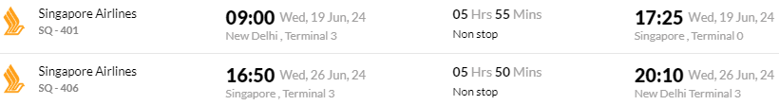

**Flight Detail: -**

**Total Flight Fare of 4 adults from Chandigarh to Singapore @INR 3,01,328/-**

