**Dear Sir/Ma’am,**

Greetings from Travanya Holidays Venture of Shipra Travels.

Thank you for giving us the opportunity to let us plan your holidays. Over the years, we have given an extra effort to maintain the customer service and managed to get 99% of our repeat customer to again book their holiday from us. With this promise, we assure you to make your holiday an unparalleled experience. We hope you enjoy your Holiday as much as we enjoyed bringing it to you.

Kindly check and confirm following details and revert on the same.

**Travel Details: -**

|  |  |
| --- | --- |
| **Destination** | **Cambodia Package** |
| **Duration** | 04 Nights / 05 Days |
| **No. of People** | 14 Adults |
| **Date** | 14 Jul 2024 to 19 Jul 2024 |

**Flight Details: -**

**Flight Fare: - @INR 54,463/- per person**

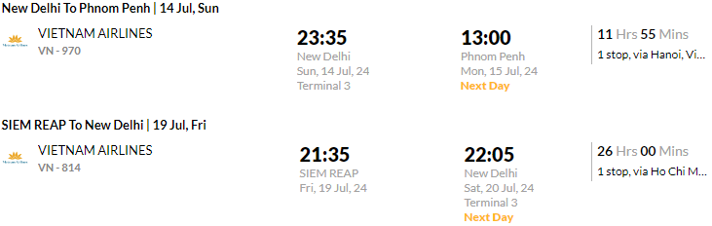

**Hotel Details: -**

**Option 1**

**Only Land Package cost:** - **@INR 31,442/-** Per Person on double sharing **(3*)**

|  |  |  |  |  |
| --- | --- | --- | --- | --- |
| **Destination** | **Hotel** | **Rooming** | **No. of Nights** | **Meal Plan** |
| Phnom Penh | **Samnang Laor Hotel/ Similar** | Superior Room | 01 | Breakfast |
| Siem Reap | **Ta Prohm Hotel/ Similar** | Superior Room | 03 | Breakfast |

**Option 2**

**Only Land Package cost:** - **@INR 33,777/-** Per Person on double sharing **(4*)**

|  |  |  |  |  |
| --- | --- | --- | --- | --- |
| **Destination** | **Hotel** | **Rooming** | **No. of Nights** | **Meal Plan** |
| Phnom Penh | **Dyvith Hotel/ Similar** | Premier No Balcony | 01 | Breakfast |
| Siem Reap | **Hari Residence & Spa/ Similar** | Deluxe Room | 03 | Breakfast |

**Option 3**

**Only Land Package cost:** - **@INR 44,915/-** Per Person on double sharing **(5*)**

|  |  |  |  |  |
| --- | --- | --- | --- | --- |
| **Destination** | **Hotel** | **Rooming** | **No. of Nights** | **Meal Plan** |
| Phnom Penh | **Sokha Phnom Penh Hotel/ Similar** | Deluxe Room | 01 | Breakfast |
| Siem Reap | **Borei Angkor Resort/ Similar** | Deluxe Room | 03 | Breakfast |

**Package Inclusions**

* One-night accommodation in Phnom Penh.
* Three Nights’ accommodation in Siem Reap.
* Accommodation for 04 nights with breakfast.
* Private English-speaking tour guide.
* Private A/C Vehicle with a Driver.
* Entrance fee as mentioned in the itinerary.
* Private boat trip at Kampong Phluk Floating Village.
* Shuttles Bus from Phnom Penh to Siem Reap per way.
* Accommodation at hotel as mentioned or similar ones

**Tentative Itinerary**

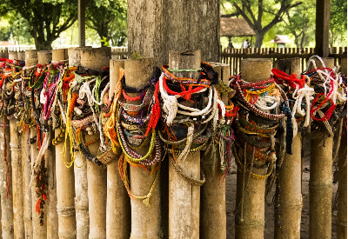 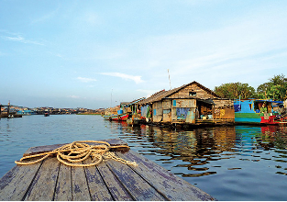 

**DAY 01: ARRIVAL PHNOM PENH - Flight: To be advised.**

Welcome to the **Pearl of Asia** – **Phnom Penh**! Upon arrival at Phnom Penh check-in the Hotel and take a rest as your wish.

*Meal: none.*

*Accommodation: At hotel in Phnom Penh.*

**DAY 02: PHNOM PENH-SIEM REAP: City Tour – Shuttle Bus to Siem Reap (B)**

In the morning, visit the notorious **Toul Sleng Genocide Museum**. Before 1975 Toul Sleng was a high school. When Khmer Rouge came to power in 1975, they converted it into the S-21 prison. **Royal Palace**, situated on the site of the former citadel and built by King Norodom in 1966, the Palace still serves as the King and Queen's residential quarters. Also, within the walls of the Palace is the **Silver Pagoda**, so called because of the five thousand silver tiles that line its exquisite floor. Continues to **Wat Phnom** – the name of a pagoda, was built by lady Daun Penh in 1372 on a little hill, Legend has it that after a particularly heavy flood, a wealthy Khmer woman named Daun Penh found a tree on the banks of the Mekong with four statues of Buddha hidden inside.

In the afternoon, transfer to Siem Reap by Shuttle Bus **(Air-Bus)**, this journey will take around 5,5 hours. You will pass through provincial towns, villages, and roadside hamlets giving you some insights into life in the Cambodian countryside.

Welcome to the **Ancient town** – **Siem Reap**! Upon arrival at the **Bus Station**, Our Tour guide & driver will welcome you and transfer you to the Hotel for check-in. Take a rest as you wish.

*Meal: Breakfast.*

*Accommodation: At hotel in Siem Reap.*

**DAY 03: SIEM REAP: Angkor Wat - Angkor Thom – Preah Khan – Ta Prom (B)**

Explore Angkor's ancient wonders with a new group of friends! The first stop is the **Angkor Thom complex**. Within these magnificent walls, you'll discover the fascinating beauty of **Bayon** and the world-famous **Ta Prohm** (Tomb Raider) Temple. Following that, satiate your hunger at one of the many local restaurants within the Angkor Complex with some delicious Cambodian cuisine! Your final two stops will be at the massive and gorgeous **Angkor Wat**, followed by a stunning sunset view from the top of **Phnom Bakheng**. The temples on this tour are among the largest in the Angkor Complex, and Phnom Bakheng has a 300-person limit at the peak, so we keep the temple count low to ensure enough time at each spectacular stop! We'll return to town once the sun has set (around 6:30 p.m.).

*Meal: Breakfast.*

*Accommodation: At hotel in Siem Reap.*

**DAY 04: SIEM REAP: City Tour – Kampong Phluk Floating Village (B)**

Explore the town to see giant Fruit Bats that live in the **Royal Residence Garden** and Baddish Temple called, **Preah Ang Chek – Preah Ang Chom**. Then continue to Wat Bo, a large, highly respected pagoda, founded in the 18th Century. Like the Silver Pagoda in Phnom Penh, the Vihear of Wat Bo contains unique wall paintings of the Reamker that are said to be late 19th Century. Visit the Cambodian Handicrafts at Satch, a center that promotes Cambodian know-how with a new artistic approach that combines traditional knowledge and contemporary design in a green and lush environment.

In the afternoon, continue to one of the stunning villages on stilts **Kampong Phluk Village** (the name means Harbor of the Tusks). Due to the increase in volume up to 10 times of the Tonle Sap Lake towards the end of the rainy season, all the fishing villages adjacent to it are built on stilts as high as 6-7 meters. The village has not yet been invaded by mass tourism, and only one trip to get there will be an unforgettable experience. Between the village and the lake in a canoe, you can visit the picturesque floodplain forest, and take photo before returning to Siem Reap Town.

*Meal: Breakfast.*

*Accommodation: At hotel in Siem Reap.*

**DAY 05: DEPARTURE FLIGHT** **(B)**

Free and easy time at leisure this morning or take a self-guided walk till transfer to the airport for departure flight.

*Meal: Breakfast.*

**SUPPLEMENT FOR MEAL IN SIEM REAP:**

Indian Food: - @USD 18 (INR 1521) Lunch per Pax per meal

@USD 22 (INR 1859) Dinner per Pax per meal

**SUPPLEMENT FOR MEAL IN PHNOM PENH:**

Indian Food: - @USD 20 (INR 1690) Lunch per Pax per meal

@USD 22 (INR 1859) Dinner per Pax per meal

**Exclusions: -**

* Airport Taxes
* Visa
* Travel Insurance
* Govt. Tax of 9%
* Tips to Driver and Guide
* Personal expense
* High Season Surcharges as applicable
* Use of vehicle other than the specified itinerary.
* Any item that is not mentioned in the above Tour Price includes
* All entrance fees and excursions not mentioned above

***Note:*** *The flight fare and land package cost are separate and is subject to availability*

**Payment Policy**

60+ Days from DOT - Non-refundable component + 25% of land package

45 to 60 Days from DOT - Non-refundable component + 50% of land package

30 to 45 Days from DOT - Non-refundable component + 80% of land package

30 days from DOT - 100% of Package Cost

***Note:*** *Full payment of Flight ticket is required before issuance*

**Payment Link**

<https://www.travanya.com/make-payment/>

**Bank Details**

|  |  |
| --- | --- |
| **Bank Name** | **HDFC Bank LTD** |
| **Account No** | 59210000002222 |
| **Name** | SHIPRA TRAVELS PVT LTD |
| **IFSC CODE** | HDFC0001321 |
| **Branch** | SWASTIK VIHAR, Panchkula |

**Cancellation Policy**

30+ Days from DOT - Non-refundable Component

30 to 15 Days from DOT - Non-refundable component + 50% of land package

15 to 7 Days from DOT - Non-refundable component + 75% of land package

15 days from DOT - 100% of Package Cost

***Note:*** *Travel Insurance is non-refundable after issuance*

**Terms & Conditions**

* Passport of all the passengers is required at the time of booking.
* Passport should be valid at-least 6 months from your return date.
* PAN card is mandatory for International Travel.
* No Bookings are made at the time of Quotation.
* Token amount is always non-refundable.
* Hotels and Services as mentioned above are subject to confirmation.
* Any Additional Tax of the respective Country, city, sightseeing is to be paid by customer directly.
* Standard Check in Time is 1400 hrs and Check out is 1200 hrs.
* Early Check-in & late check out is chargeable. Complimentary early check-in and late checkout is subject to availability.
* Any Change in VISA fees, Policies and Govt. taxes will be levied before departure date.
* Addition of Any services on ground directly by the customer will not be responsibility of Travanya.
* Any Tip for any service is to be paid directly by customer that cannot be a part of package
* We should not be held responsible for acceptance and rejection of VISA. Its sound decision concerned Embassy
* Any sudden rise in Airfare, Hotel rates & other ground service charges should be borne by customer.
* GST & TCS of 5% each is required if payment is in INR currency and for other currency ROE is calculated as per Date of payment.
* Travanya should not be held responsible for any cancellation and changes due to any natural Calamity.

