## Dear Sir/Ma’am,

Greetings from Travanya.com !!

Thank you for giving us the opportunity to let us plan your holidays. Over the years, we have given an extra effort to maintain the customer service and managed to get 99% of our repeat customer to again book their holiday from us. With this promise, we assure you to make your holiday an unparalleled experience. We hope you enjoy your Holiday as much as we enjoyed bringing it to you.

Kindly check and confirm following details and revert on the same.

**Travel Details: -**

|  |  |
| --- | --- |
| **Destination** | **Bali Holiday Package** |
| **Duration** | 05 Nights / 06 Days |
| **No. of People** | 02 Adults |
| **Date** | 04 Aug 2024 to 09 Aug 2024 |
| **Total Package Cost** | INR 204932/- INCLUDING FLIGHTS WITH 4* HOTEL  INR 216904/- INCLUDING FLIGHTS WITH 5* HOTEL |

# Flight Details: -

### **Flight Fare:- BLR-DPS-BLR :- INR 62,715/- per person**

### **WLG-DPS-WLG :- INR 70,489 /- per person**

# 

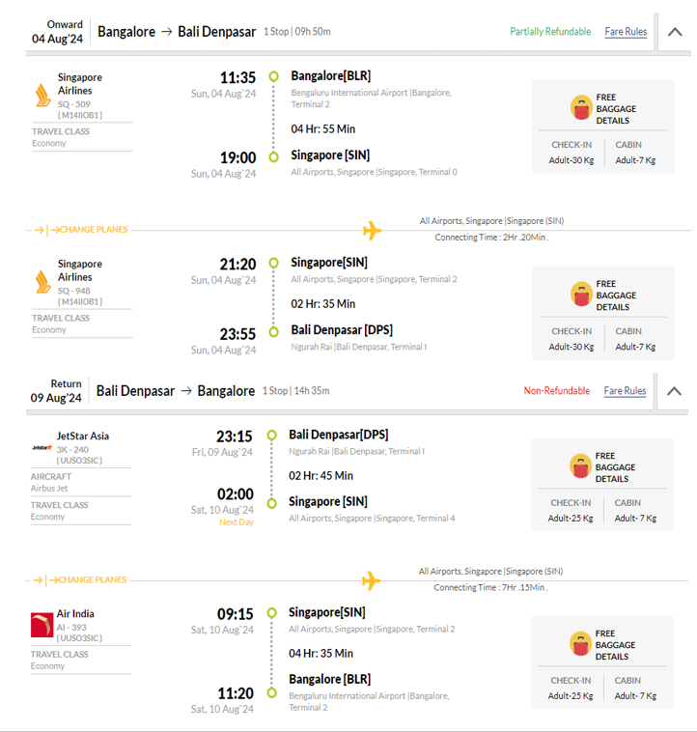

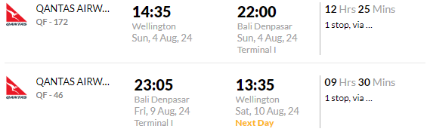

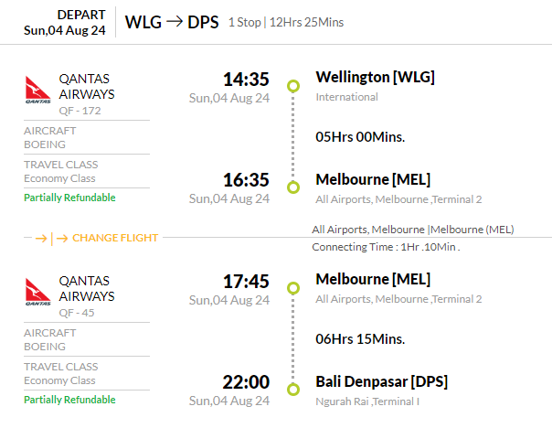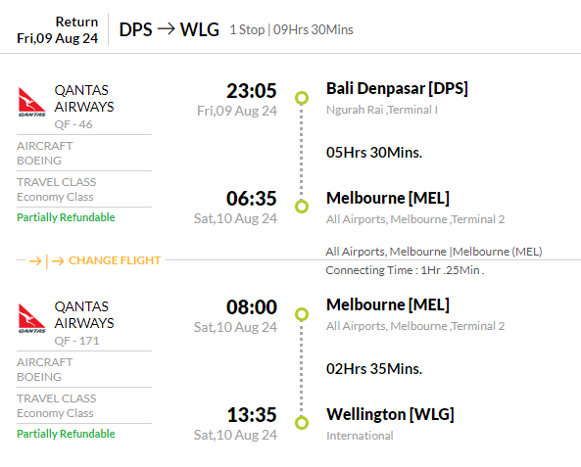

# Hotel and Sightseeing Details: -

**Option 01:**

# Only Land Package cost: - INR 35,864/- PER PERSON (Excluding Flights)

|  |  |  |  |  |
| --- | --- | --- | --- | --- |
| **Destination** | **Hotel** | **Rooming** | **No. of Nights** | **Meal Plan** |
| **Kuta** | **Eden Kuta 4*/ Similar** | **Eden Room** | **03 Nights** | Breakfast |
| **Seminyak** | **Grand Kesambi Villas**  **Seminyak 4*/ Similar** | **01 Bedroom Villa** | **02 Nights** | **Breakfast** |

# Option 02:

**Only Land Package cost: - INR 41,850 /- PER PERSON (Excluding Flights)**

|  |  |  |  |  |
| --- | --- | --- | --- | --- |
| **Destination** | **Hotel** | **Rooming** | **No. of Nights** | **Meal Plan** |
| **Seminyak** | **Jambuluwuk Oceano Seminyak Hotel 5*/ Similar** | **Superior Room** | **03 Nights** | **Breakfast** |
| **Ubud** | **Furama Xclusive Resort And**  **Villas Ubud 5*/ Similar** | **01 Bedroom Deluxe**  **Pool Villa** | **02 Nights** | **Breakfast** |

## Inclusions: -

* **05 Nights’** Accommodation at the above mention hotels
* **Daily breakfast**
* Meet & Greet assistance at the airport and transfer directly to your hotel
* Transfers with air-conditioned vehicle
* English speaking driver cum guide assistance
* Full Day Tour with Benoa water sports including 1 x round of Banana boat, Parasailing, and Jet skii + Uluwatu sunset temple Tour followed by Kecak Dance on private transfers
* West Nusa Penida tour with transfer and ferry ( 1 point snorkelling day trip) on private basis Tour Include : Car for tour island, Driver as Guide, Return Boat Free entrance all destination, only Snorkeling Equipment, Life Jacket
* Kintamani tour with Ubud Village + My SWING - (2 Single Swing, Fun Adrenaline Swing, Exciting Adrenaline Swing, Ultimate Swing, Couple Swing, Romantic Bed Swing, Family Bed Swing, Chicken Nest, Bird Nest, Sweet Love Nest, Glass Floor) WITH TRANSFERS
* Rafting LONG 12KM (Ayung river) + (Kuber ATV tandem ride - Duration : -+1,5 hours , Welcome drink, Insurance, Local Lunch, Boots and Helmet , Bath equipment - Open from 8 am , last session 3 pm ) with private transfers
* Return Airport transfer by Pvt Basis
* TCS 5% Included
* GST 5% Included

## Exclusions: -

* + Any Kind of Personal Expenses or Optional Tours / Extra Meals Ordered
  + Tour Exclude : Retribution fee to Island Nusa Penida IDR 25.000,-/person.
  + Services of local tour guide.
  + Anything not specifically mentioned under the head “Inclusions”.
  + Tips, Insurance, Laundry, Phone Calls.
  + Any kind of drinks (Alcohol, Aerated)

***Note:*** *The flight fare and land package cost is separate and is subject to availability*

## Payment Policy

|  |  |
| --- | --- |
| 60+ Days from DOT - | Non-refundable component + 25% of land package |
| 45 to 60 Days from DOT - | Non-refundable component + 50% of land package |
| 30 to 45 Days from DOT - | Non-refundable component + 80% of land package |
| 30 days from DOT - | 100% of Package Cost |

***Note:*** *Full payment of Flight ticket is required before issuance*

**Payment Link** <https://www.travanya.com/make-payment/>

## Bank Details

|  |  |
| --- | --- |
| **Bank Name** | **HDFC Bank LTD** |
| **Account No** | 59210000002222 |
| **Name** | SHIPRA TRAVELS PVT LTD |
| **IFSC CODE** | HDFC0001321 |
| **Branch** | SWASTIK VIHAR, Panchkula |

**Cancellation Policy**

|  |  |
| --- | --- |
| 30+ Days from DOT - | Non-refundable Component |
| 30 to 15 Days from DOT - | Non-refundable component + 50% of land package |
| 15 to 7 Days from DOT - | Non-refundable component + 75% of land package |
| 15 days from DOT - | 100% of Package Cost |

***Note:*** *Travel Insurance is non-refundable after issuance*

## Terms & Conditions

* Passport of all the passengers is required at the time of booking.
* Passport should be valid at-least 6 months from your return date.
* PAN card is mandatory for International Travel.
* No Bookings are made at the time of Quotation.
* Token amount is always non-refundable.
* Hotels and Services as mentioned above are subject to confirmation.
* Any Additional Tax of the respective Country, city, sightseeing is to be paid by customer directly.
* Standard Check in Time is 1400 hrs and Check out is 1200 hrs.
* Early Check-in & late check out is chargeable. Complimentary early check-in and late checkout is subject to availability.
* Any Change in VISA fees, Policies and Govt. taxes will be levied before departure date.
* Addition of Any services on ground directly by the customer will not be responsibility of Travanya.
* Any Tip for any service is to be paid directly by customer that cannot be a part of package
* We should not be held responsible for acceptance and rejection of VISA. Its sound decision concerned Embassy
* Any sudden rise in Airfare, Hotel rates & other ground service charges should be borne by customer.
* GST & TCS of 5% each is required if payment is in INR currency and for other currency ROE is calculated as per Date of payment.
* Travanya should not be held responsible for any cancellation and changes due to any natural Calamity.

