**DAY 1 - WELCOME TO BAKU. PANORAMIC TOUR**

* 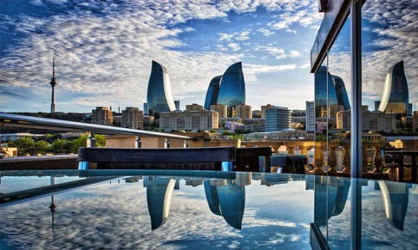Arrival at Airport
* Transfer from Airport
* Assembly at hotel lobby in sunset time. **Proceed to evening city view tour with car**
* Visit to **Highland Park**-Alley of Martyrs, The National Assembly- also transliterated as Milli Majlis, Flame towers- the tallest skyscraper in Baku.
* **Back to Hotel**

**DAY 2 – BAKU CITY TOUR**

* Breakfast in Hotel
* 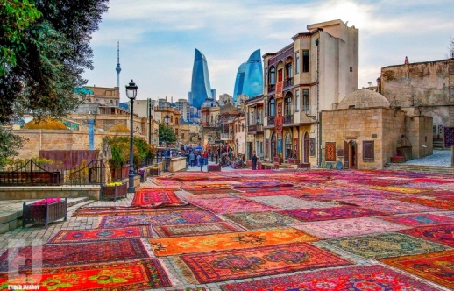Our tour program starts with **Old City**or Icheri Sheher is the historical core of [Baku](https://en.wikipedia.org/wiki/Baku), the capital of [Azerbaijan](https://en.wikipedia.org/wiki/Azerbaijan). The Old City is the most ancient part of Baku, which is surrounded by walls were well protected. In 2007, the Old City had a population of about 3000 people. In December 2000, the Old City of Baku, including the [Palace of the Shirvanshahs](https://en.wikipedia.org/wiki/Palace_of_the_Shirvanshahs)’ and [Maiden Tower](https://en.wikipedia.org/wiki/Maiden_Tower_(Baku)) ( Giz Galasi ), became the first location in [Azerbaijan](https://en.wikipedia.org/wiki/Republic_of_Azerbaijan) to be classified as a [World Heritage Site](https://en.wikipedia.org/wiki/World_Heritage_Site) by [UNESCO](https://en.wikipedia.org/wiki/UNESCO). (walking tour)
* 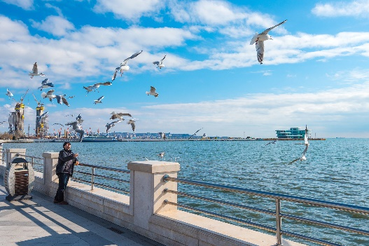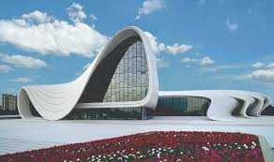Tour continues with the visit to the charming example of modern architecture - The **Heydar Aliyev Center** – a 57,500 m2 building complex in Baku, Azerbaijan designed by Iraqi-British architect Zaha Hadid and noted for its distinctive architecture and flowing, curved style that eschews sharp angles. The center is named after Heydar Aliyev, the first secretary of Soviet Azerbaijan from 1969 to 1982, and president of Azerbaijan Republic from October 1993 to October 2003. **(Photo shoot outside)**
* Walking through **Baku Boulevard** which stretches along a south-facing bay on the Caspian Sea. It traditionally starts at Freedom Square continuing west to the Old City and beyond. Since 2012, the Yeni Bulvar (New Boulevard) has virtually doubled the length to 3.75 km.
* **Back to Hotel**

**DAY 3 – FLAMES TOUR**

* 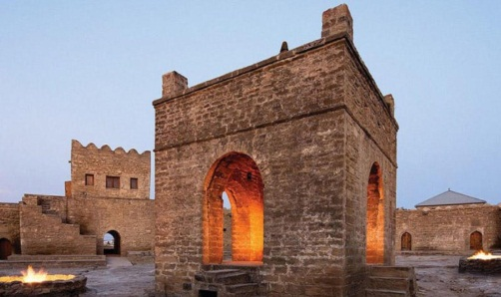Breakfast in Hotel
* Tour starts with **Ateshgah** (Fire Worshippers Temple) Based on Persian and Indian inscriptions, the temple was used as a [Hindu](https://en.wikipedia.org/wiki/Hindu) and [Zoroastrian](https://en.wikipedia.org/wiki/Zoroastrianism) place of worship. “Atash» is the Persian word for fire. The pentagonal complex , which has a courtyard surrounded by cells for monks and a tetra pillar-altar in the middle, was built during the 17th and 18th centuries.
* 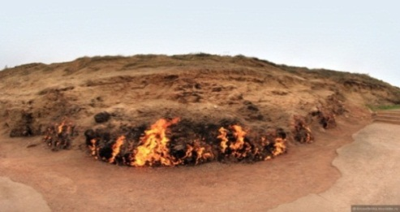Trip to “**Fire Mountain** “- “Yanardag” –a mountain on Absheron peninsula, 25 km from north of Baku. Literally, word “Yanardag” means “Blazing mountain”. Blazing bodies of flame dance on stones and floor. Yanar dag is a natural gas fire which blazes continuously on a hillside on the Absheron Peninsula on the Caspian Sea near Baku, the capital of Azerbaijan, which itself is known as the “land of fire.”
* 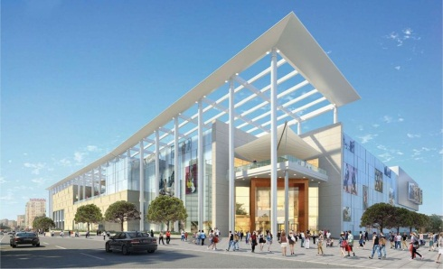**Ganjlik Mall:** - located in 10 minutes distance form city center with taxi. Ganjlik mall is the biggest Mall in Baku and contains over 80 stores, big bowling halls, the biggest movie halls, 3D cinema, Playground for children, Bravo supermarket, VIP restaurants, food courts
* **Back to Hotel**

**DAY 4 – SHOPPING TOUR**

* Breakfast in Hotel

**Bakhlava Tasting**

* 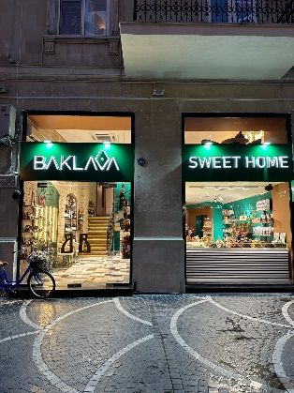Bakhlava is the most famous sweet of Azerbaijan which is called paxlava by locals.That is also the symbol Nowruz which is the national holiday of Azerbaijan.There are different kind of bakhlava such as Baku,Guba,Sheki,etc and each of them has their own taste.It is one of the best gift for your beloved ones. The ingredients of Azerbaijani bahklava is cardamom,saffron,nuts (hazelnut,walnut and almond),honey.

`` **Baklava Sweet Home** ``is one of the best pastry for bakhlava which you can even taste the traditional sweets of Azerbaijan.

* 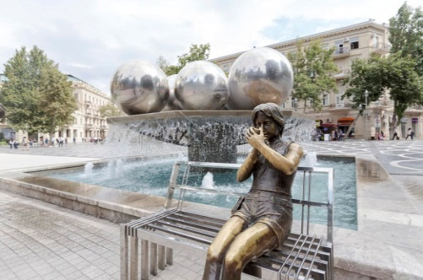Group will experience the happening street of **Nizami Street** known for shopping. The street's history could be traced back to Baku's town-planning project of 1864. The street runs through the city's downtown from west to east. It begins from [Abdulla Shaig](https://en.wikipedia.org/wiki/Abdulla_Shaig) Street, in mountainous part of the city and ends at railroad bed on [Sabit Orujov](https://en.wikipedia.org/wiki/Sabit_Orujov) Street, near a monument to [Shah Ismail Khatai](https://en.wikipedia.org/wiki/Ismail_I) in “Black City”. Total length of the street is 3,538 m.
* **Fountains Square**is a public square in downtown [Baku](https://en.wikipedia.org/wiki/Baku), capital of [Azerbaijan](https://en.wikipedia.org/wiki/Azerbaijan). The name of the fountains square derives from the presence of dozens of fountains throughout the square first constructed during Soviet rule of Azerbaijan. The square is a public gathering place, especially after business hours and during the weekend.
* **Back to Hotel**

**DAY 5 – DEPARTURE**

* Breakfast in Hotel
* Departure to Airport for return flight

|  |  |  |
| --- | --- | --- |
| Diamond 3* | DBL | 255 |
| Atlas 3* | DBL | 235 |
| Austin 4* | DBL | 265 |
| Grand central park 4* | DBL | 275 |

**1 PAX/USD/PP FOR**

**Child 0-5 y.o free of charge only visa 26$**

**Child 6-11 y.o 50% of charge**

**INCLUSIONS:**

* Accommodation in Hotel including breakfast: 4 nights in Baku,
* Sightseeing in districts **Baku, Absheron,**
* English speaking driver
* Entrance fee: Flame temple, Fire mountain,
* 2 Bottles of water per person per day
* All transfers according to program including airport transfers: Sedan
* Standard Visa

**EXCLUSIONS:**

**»** Anything not mentioned in inclusions.

**»** Porter service.

**»** Hard drinks.

**»** Charges in hotels for additional services & penalties.

**»** Any additional persons joining the group at the destination or any of the services will need to pay

**NOTE:**

**»** The Hotel check-in time 15:00 PM and check-out time is 12:00 PM.

**»** In the restaurants duration for having meals is 1 Hours normal dinner and lunches

**»** Outside liquor is not allowed in the restaurants. Corkage charge is – 20-30 USD per bottle

**»** Meals should be eaten at the restaurant; we are not responsible for take away. For cancellation or change for any restaurant information should be given minimum 48 hours before for free cancellation.

**»** The vehicle will move accordingly to time schedule mentioned on program. All group should leave Hotel for dinners on given time in the program for starting tour in the morning and moving for dinners in the evenings.

**CANCELLATION POLICY:**

» 48 hours prior to arrival All services are refundable (except hotel it depends on hotel policy)

» After 48 hours prior to arrival 1st night services are non-refundable rest days services refundable (except hotel it depends on hotel policy)

» Refundable services are: Entrance Tickets, Meals

Note: If number of cancelled people effects on group price, we will recalculate the price. Rates are not available for Block out and Holiday dates