**DAY 1 - WELCOME TO BAKU. BAKU CITY TOUR**

* Arrival at Airport
* Transfer from Airport to the Hotel.
* Accommodation in hotel. Free time.
* Breakfast in Hotel
* 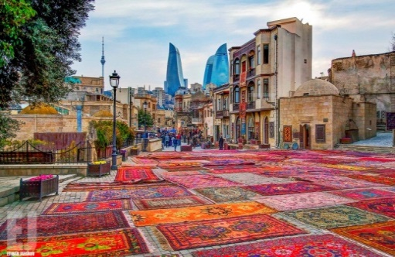Our tour program starts with **Old City**or Inner City is the historical core of [Baku](https://en.wikipedia.org/wiki/Baku), the capital of [Azerbaijan](https://en.wikipedia.org/wiki/Azerbaijan). The Old City is the most ancient part of Baku, which is surrounded by walls were well protected. In 2007, the Old City had a population of about 3000 people. In December 2000, the Old City of Baku, including the [Palace of the Shirvanshahs](https://en.wikipedia.org/wiki/Palace_of_the_Shirvanshahs) and [Maiden Tower](https://en.wikipedia.org/wiki/Maiden_Tower_(Baku)), became the first location in [Azerbaijan](https://en.wikipedia.org/wiki/Republic_of_Azerbaijan) to be classified as a [World Heritage Site](https://en.wikipedia.org/wiki/World_Heritage_Site) by [UNESCO](https://en.wikipedia.org/wiki/UNESCO) (walking tour)
* **Lunch at Indian Restaurant**
* 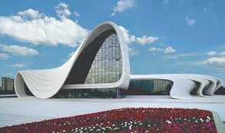Tour continues with the visit to the charming example of modern architecture - The **Heydar Aliyev Center** – a 57,500 m2 building complex in Baku, Azerbaijan designed by Iraqi-British architect Zaha Hadid and noted for its distinctive architecture and flowing, curved style that eschews sharp angles. The center is named after Heydar Aliyev, the first secretary of Soviet Azerbaijan from 1969 to 1982, and president of Azerbaijan Republic from October 1993 to October 2003. **(Photoshoot outside)**
* Walking through **Baku Boulevard** which stretches along a south-facing bay on the Caspian Sea. It traditionally starts at Freedom Square continuing west to the Old City and beyond. Since 2012, the Yeni Bulvar (New Boulevard) has virtually doubled the length to 3.75 km.
* **Dinner in Indian Restaurant**
* **Back to Hotel**

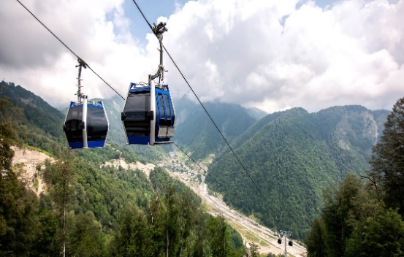**DAY 2 -GABALA TOUR**

* Breakfast in Hotel.
* Check out Hotel
* Proceed to Departure to **Gabala** in the north-west of Azerbaijan the distance up to Baku 225 km (4 hours)
* **Lunch at Indian Restaurant**
* Excursion in: Tufandaq Winter-Summer Tourism Complexoffers cable car rides at any time of the year, skiing on the ski tracks of different difficulty level, ski training and ski school, catering service (cafe and restaurants), entertainment centres for kids, hotel and other services.
* 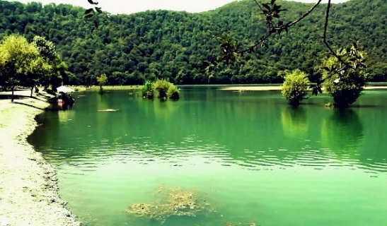Nohur Lake-It is located in Qabala. Lake is not on the way but if you go a bit deeper towards the mountains this beautiful view opens up in front of you.
* **Dinner at Indian Restaurant**
* Back o Hotel

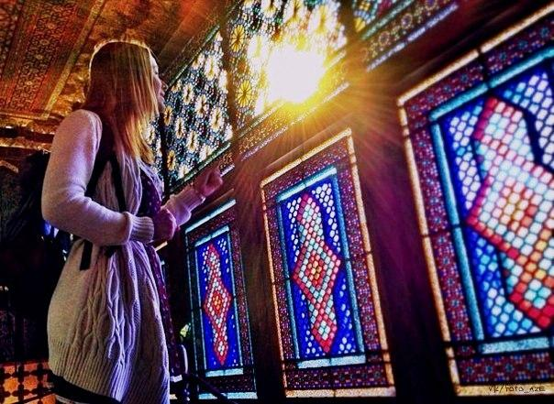**DAY 3 - SHEKI TOUR**

* Breakfast in Hotel
* Check out Hotel
* Visit the Palace of **Sheki Khan’s Palace** in which was a summer residence of Shaki Khans. It was constructed in 1761-1762 as a summer residence of Hussein-khan Mushtad (grandson of Gadzhi Chelebi). The basic material for the Palace construction was raw bricks, river stones, plane trees and oaks. The most amazing is that not a single nail or glue drop was used for the construction! Everything is in place due to a special solution the formula of which was lost forever.
* **Lunch at Indian Restaurant**
* 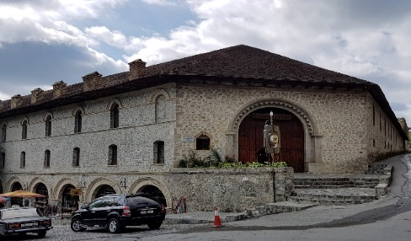Later visit **Caravanserais.** Swift development of trade in the Middle Ages enhanced importance of caravanserai existing in the territory of Azerbaijan at that time and favored construction of new ones. Generally, caravanserai was built in form of castles with one gate, closing of which made them impregnable during dangerous incidents.
* 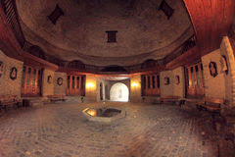The **Church of Kish,** also known as Church of Saint Elishe or Holy Mother of God Church is an inactive 12th or 13th century Caucasian Albanian church located in the village of Kish approximately 5 km north of [Shaki](https://en.wikipedia.org/wiki/Shaki,_Azerbaijan).  The church became the "spiritual center and the place of enlightenment of people of the East".
* Back to Baku
* **Dinner at Indian Restaurant**
* Check in Hotel

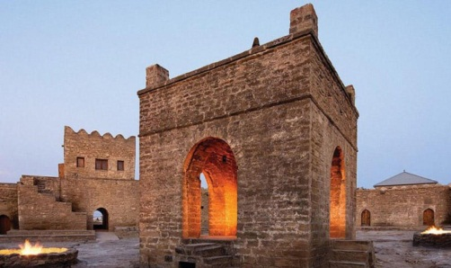**DAY 4 – FLAME TOUR**

* Breakfast in Hotel
* Tour starts with **Ateshgah** (Fire Worshippers Temple) Based on Persian and Indian inscriptions, the temple was used as a [Hindu](https://en.wikipedia.org/wiki/Hindu) and [Zoroastrian](https://en.wikipedia.org/wiki/Zoroastrianism) place of worship. “Atash» is the Persian word for fire. The pentagonal complex, which has a courtyard surrounded by cells for monks and a tetra pillar-altar in the middle, was built during the 17th and 18th centuries.
* 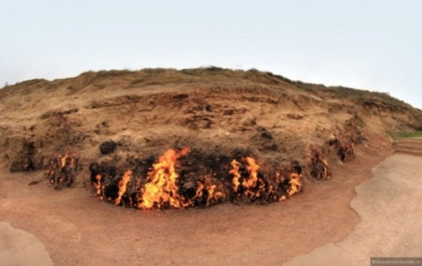Trip to “**Fire Mountain** “-“Yanardag” –a mountain on Absheron peninsula, 25 km from north of Baku. Literally, word “Yanardag” means “Blazing mountain”. Blazing bodies of flame dance on stones and floor. Yanar dag is a natural gas fire which blazes continuously on a hillside on the Absheron Peninsula on the Caspian Sea near Baku, the capital of Azerbaijan, which itself is known as the “land of fire.”
* **Lunch in Local Restaurant**
* 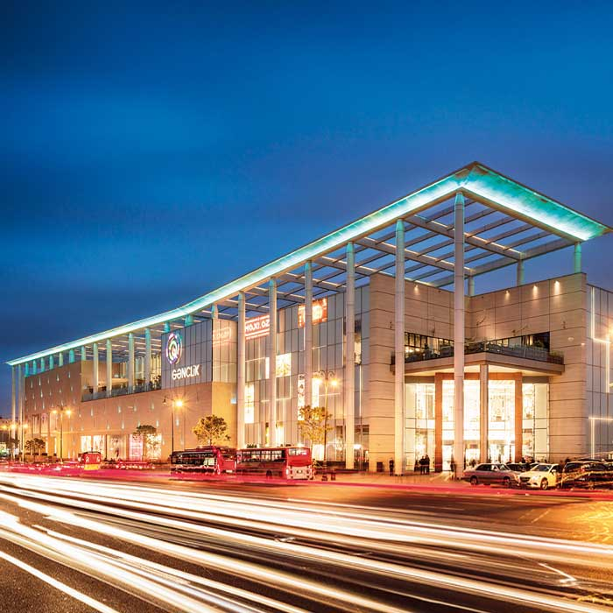Start shopping tour with **Ganjlik Mall**: - located in 10 minutes distance form city center with taxi. Genclik mall is the biggest Mall in Baku and contains over 80 stores, big bowling halls, the biggest movie halls, 3D cinema, Playground for children, Bravo supermarket, VIP restaurants, food courts
* **Dinner in Local Restaurant**
* **Back to Hotel**

**DAY 5 – GOBUSTAN TOUR**

* Breakfast in Hotel
* 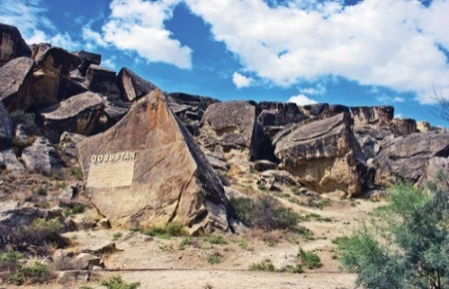Tour starts with **Qobustan** which is best known for being the home to the famous rock petroglyphs. The area has been settled since the 8th millennium BC. It is known for hosting thousands of rock engravings spread over 100 square km depicting hunting scenes, people, ships, constellations and animals. Its oldest petroglyphs date from the 12th century BC. In 2007, UNESCO included the ‘Gobustan Rock Art Cultural Landscape’ in the World Heritage list.
* Visit to Mud Volcano
* 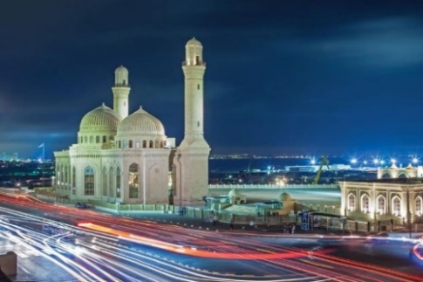The **Bibi-Heybat Mosque** is a historical mosque in [Baku](https://en.wikipedia.org/wiki/Baku), [Azerbaijan](https://en.wikipedia.org/wiki/Azerbaijan). The existing structure, built in the 1990s, is a recreation of the mosque with the same name built in the 13th century by [Shirvanshah](https://en.wikipedia.org/wiki/Shirvanshah" \o "Shirvanshah) Farrukhzad II Ibn Ahsitan II, which was completely destroyed by the [Bolsheviks](https://en.wikipedia.org/wiki/Bolsheviks) in 1936. The Bibi-Heybat Mosque includes the tomb of Ukeyma Khanum (a descendant of The Islamic Prophet [Muhammad](https://en.wikipedia.org/wiki/Muhammad)), and today is the spiritual center for the Muslims of the region and one of the major monuments of [Islamic architecture](https://en.wikipedia.org/wiki/Islamic_architecture) in Azerbaijan.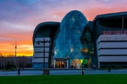
* **Lunch in Local Restaurant**
* Start shopping in **Park Boulevard** which is a multi-story shopping mall located on Baku Boulevard, downtown Baku, Azerbaijan. The mall is located 5 minutes of walking distance from Sahil Metro station of Baku Subway and Government House of Baku. The building has all architectural attributes of the East and modern art of the West. It consists of six floors, including two underground floors. The general area of the mall is 17,000 square metres. It also has a parking lot for 550 automobiles
* **Dinner in Local Restaurant**
* **Back to Hotel**

**DAY 6 – SHOPPING TOUR & DEPARTURE**

* Breakfast in Hotel
* 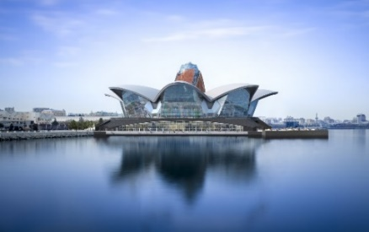Start Shopping tour with Local Sweet Shop, Baklava
* 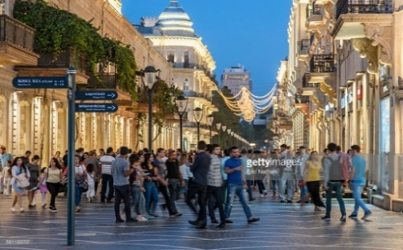Continue with **Deniz mall**: Located on land reclaimed from the Caspian Sea, Deniz Mall is a 120,000m² entertainment, leisure and dining destination over five floors. With its unique architectural concept, it will host brands such as Casa Culinary Art School of Azerbaijan, Beverly Hills and Chill Box, Big Chef, TGI Friday, Dine Hall, Kinderland for the first time in Azerbaijan, along with several well-known brands such as Starbucks, Nike, Swarovski, Pandora, Paul, Go Sport, Alma Store, LVIV Handmade Chocolate, Cinema Plus
* **Lunch at Indian Restaurant**
* Later group will experience the happening street of **Nizami Street** known for shopping. The street's history could be traced back to Baku's town-planning project of 1864. The street runs through the city's downtown from west to east. It begins from [Abdulla Shaig](https://en.wikipedia.org/wiki/Abdulla_Shaig) Street, in mountainous part of the city and ends at railroad bed on [Sabit Orujov](https://en.wikipedia.org/wiki/Sabit_Orujov" \o "Sabit Orujov) Street, near a monument to [Shah Ismail Khatai](https://en.wikipedia.org/wiki/Ismail_I) in “Black City”
* **Dinner at Indian Restaurant**
* Departure to Airport for return flight

**INCLUSIONS:**

* Accommodation in Hotel including breakfast (5 nights in Baku + (1 night early check in), 1-night Gabala)
* Sightseeing in districts **(Baku, Absheron, Gabala, Shaki, Gobustan)**
* English speaking guide
* Lunch and Dinner
* Entrance fee for Flame temple, Fire mountain, Mud Volcano, Gobustan, Little Venice boat ride, funicular ride, Cable car in Gabala (2 lines), Shaki Khan Palace
* 2 Bottles of water per person per day
* All transfers according to program including airport transfers: Sprinter
* Visa (standard)

**EXCLUSIONS:**

**»** Anything not mentioned in inclusions.

**»** Porter service.

**»** Hard drinks.

**»** Charges in hotels for additional services & penalties.

**»** Any additional persons joining the group at the destination or any of the services will need to pay

**NOTE:**

**»** The Hotel check-in time 15:00 PM and check-out time is 12:00 PM.

**»** In the restaurants duration for having meals is 1,5 Hours normal dinner and lunches

**»** Outside liquor is not allowed in the restaurants. Corkage charge is – 20-30 USD per bottle

**»** Meals should be eaten at the restaurant, we are not responsible for take away. For cancellation or change for any restaurant information should be given 24 hours before for free cancellation.

**»** The vehicle will move accordingly to time schedule mentioned on program. All group should leave Hotel for dinners on given time in the program for starting tour in the morning and moving for dinners in the evenings.

**CANCELLATION POLICY:**

**»** 48 hours prior to arrival All services are refundable (except hotel it depends on hotel policy)

**»** After 48 hours prior to arrival 1st night services are non-refundable rest days services refundable (except hotel it depends on hotel policy)  
**»** Refundable services are: Entrance Tickets, Meals   
  
Note: If number of cancelled people effects on group price, we will recalculate the price. Rates are not available for Black out and Holiday dates