**Dear Sir/Ma’am,**

Greetings from Travanya Holidays Venture of Shipra Travels.

Thank you for giving us the opportunity to let us plan your holidays. Over the years, we have given an extra effort to maintain the customer service and managed to get 99% of our repeat customer to again book their holiday from us. With this promise, we assure you to make your holiday an unparalleled experience. We hope you enjoy your Holiday as much as we enjoyed bringing it to you.

Kindly check and confirm following details and revert on the same.

**Travel Details: -**

|  |  |
| --- | --- |
| **Destination** | **Cambodia Package** |
| **Duration** | 04 Nights / 05 Days |
| **No. of People** | 14 Adults |
| **Date** | 14 Jul 2024 to 19 Jul 2024 |

**Flight Details: -**

**Flight fare: - INR 46,023/-** per person

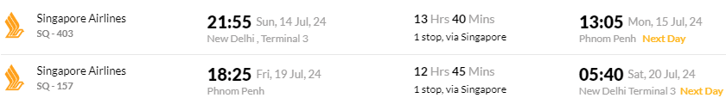

**Hotel Details: -**

**Only Land Package cost:** - **@INR 49,812/-** Per Person on double sharing **(4*)**

|  |  |  |  |  |
| --- | --- | --- | --- | --- |
| **Destination** | **Hotel** | **Rooming** | **No. of Nights** | **Meal Plan** |
| Phnom Penh | **G Mekong Hotel/ Similar** | Superior room | 01 | Breakfast |
| Siem Reap | **Somadevi Angkor Hotel/ Similar** | Superior Room | 03 | Breakfast |

**Package Inclusions**

* Accommodation as mentioned above.
* Private English-speaking tour guide
* Private Minibus and driver (Minibus 25 seats)
* Cambodia Evisa
* Entrance fee to all mentioned sites
* 4 Lunch and 4 Dinner
* 2 bottles of cold water per person per day
* All taxes

**Tentative Itinerary**

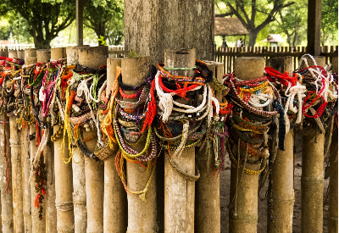 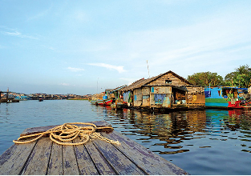 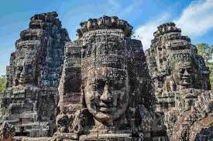

**Day1 (15th July 2024): Arrival Phnom Penh | Leisure**

**Welcome to Cambodia!**

Upon arrival in Phnom Penh, your tour guide will greet you at the airport and escort you to your hotel for check-in. The rest of the day is at your leisure.

Note: Cambodia evisa is included in your package.

In the evening your tour guide and driver will take you to a restaurant for dinner. Enjoy your

meal.

**Meal: Dinner**

**Overnight in Phnom Penh**

**Day2 (16th July 2024): Half Day City Tour | Private Transfer to Siem Reap**

After breakfast, meet your guide and driver and take a short trip to visit Toul Sleng, the Royal

Palace and the National Museum.

First, you & continue to Toul Sleng Genocide Museum. Prior to 1975 Toul Sleng was a high

school. When the Khmer Rouge came to power in 1975, they converted it into an S-21 prison.

Then, visit National Museum of Cambodia to learn about the history and culture.

Next, Royal Palace is a complex of buildings that serves as the official residence of the King of

Cambodia. The Royal Palace was built between 1866 and 1870, after King Norodom moved the capital from Oudong to Phnom Penh. It has classic Khmer architecture, with gilded roofs, ornate decorations, and a large throne hall. It is one of the most popular tourist attractions in the city, and a symbol of the Khmer culture and history.

The last is National Museum which is a museum of cultural history and archaeology in

Cambodia. It houses one of the worlds & largest collections of Khmer art, including sculptures, ceramics, bronzes, and ethnographic objects. The museum is located next to the Royal Palace in central Phnom Penh. The museum was designed by George Groslier, a French historian and curator, who was inspired by Khmer temple architecture. The museum was inaugurated in 1920 and renovated in 1968. It showcases many fine examples of Angkor Wat statuary and artifacts from prehistoric times to the Khmer Empire.

After lunch, your guide and driver will transfer you direct to Siem Reap city. The distance is

312km and it takes around 5 - 6 hours by drive. On the way, we will stop at most famous Spider market, Skuon, a market town on the highway popular for its fried spiders as a specialty snack.

You will have a chance to try it out if you wish to.

Arrive in Siem Reap, transfer to dinner, then take a rest at the hotel.

**Meal: Breakfast/Lunch/Dinner**

**Overnight in Siem Reap**

**Day3 (17th July 2024): Bantay Srei Temple | Preak Dak Village | Tonle Sap Lake**

After breakfast, your tour guide and driver will take you to Banteay Srei which take around

45mn to get there.

Note: You can start a bit late if you still feel tired from yesterday’s trip. Just inform your tour

guide in advance.

Banteay Srei Temple is a 10th-century Hindu temple in Siem Reap, Cambodia, dedicated to

Shiva and Parvati. The temple was built by Yajnavaraha, a royal counselor, and his pupil, the

future king Jayaraman V. It is famous for its pink sandstone, intricate carvings, and miniature scale. It is also known as the Citadel of Women or the Jewel of Khmer Art. It was originally named Tribhuvanamaheśvara, meaning Great Lord of the Threefold World. The temple has three enclosures, each with its own shrines and sculptures.

Next, you’ll visit Preak Dak Village. This is a traditional village in Banteay Srei district. It is

known for its handicrafts, such as silk weaving, basket making and pottery. Preak Dak Village

also has many traditional foods and cakes like Num Ban Chok, Palm Cake with coconut cream,

Num Bak Ben etc. Most tourists, including local tourists, never skip this part while they’re

visiting Siem Reap.

Kompong Pluk is a collection of three villages on the Tonle Sap Lake in Siem Reap, Cambodia.

It is home to about 3000 people who live in stilt houses and depend on fishing and tourism for their livelihood. Kompong Pluk is also known for its flooded forest, where you can see

mangrove trees wildlife and beautiful sunset. You’ll be taken back to your hotel for the evening at your leisure.

**Meal: Breakfast/Lunch/Dinner**

**Overnight in Siem Reap**

**Day4 (18th July 2024): Angkor Full Day Tour**

After breakfast, your tour guide and private vehicle pick you up at the hotel to begin your

explorations of Angkor Thom Ancient City.

On your way to Angkor Thom, you’ll catch a glimpse of the front of Angkor Wat as you pass by, which will leave you with a tingling feeling on the back of your neck as you take your first

glance at the enormity and wonder of the largest religious complex to ever exist. However, we’ll be saving dessert for last as you go today to see some other equally impressive structures of Ta Prohm Temple, Bayon Temple, Banteay Kdei, Baphoun, Elephant Terrace, Leper King Terrace, and the Royal Palace.

Finally, be prepared to enjoy one of the Seven Wonders of the World: Angkor Wat. At this point, you most probably have gotten glimpses of the towers over treetops and the gates in front in passing. But now you’ll finally get to satiate that curiosity that’s grown in the last few days.

Enter Angkor Wat and learn about the stories and amazing architecture that have stunned

archeologists, leaving more questions than answers. Angkor Wat possesses some of the most

intricate and longest stone carvings in the world. This complex is four times the size of the

Vatican City, making it the largest religious site in the world. Spend the morning adventuring

through the many passages, levels, and exploring chambers that once housed one of the many treasures of the ancient world. It will be an experience you won’t forget.

You’ll be taken back to your hotel for the late afternoon at your leisure**.**

**Meal: Breakfast/Lunch/Dinner**

**Overnight in Siem Reap**

**Day5 (19th July 2024): Private Transfer to Phnom Penh | Departure**

Today, our tour guide and driver will pick you up from the hotel lobby and transfer you from

Siem Reap city to Phnom Penh airport for your next flight. Farewell. End service.

**Meal: Breakfast/Lunch**

**Exclusions: -**

* Personal expense
* Fast Track service on arrival
* Bank transfer fee
* Airfare
* Meal and drinks during the meals
* Tipping
* Insurance
* Personal expense
* And other services are not mentioned.

***Note:*** *The flight fare and land package cost are separate and is subject to availability*

**Payment Policy**

60+ Days from DOT - Non-refundable component + 25% of land package

45 to 60 Days from DOT - Non-refundable component + 50% of land package

30 to 45 Days from DOT - Non-refundable component + 80% of land package

30 days from DOT - 100% of Package Cost

***Note:*** *Full payment of Flight ticket is required before issuance*

**Payment Link**

<https://www.travanya.com/make-payment/>

**Bank Details**

|  |  |
| --- | --- |
| **Bank Name** | **HDFC Bank LTD** |
| **Account No** | 59210000002222 |
| **Name** | SHIPRA TRAVELS PVT LTD |
| **IFSC CODE** | HDFC0001321 |
| **Branch** | SWASTIK VIHAR, Panchkula |

**Cancellation Policy**

30+ Days from DOT - Non-refundable Component

30 to 15 Days from DOT - Non-refundable component + 50% of land package

15 to 7 Days from DOT - Non-refundable component + 75% of land package

15 days from DOT - 100% of Package Cost

***Note:*** *Travel Insurance is non-refundable after issuance*

**Terms & Conditions**

* Passport of all the passengers is required at the time of booking.
* Passport should be valid at-least 6 months from your return date.
* PAN card is mandatory for International Travel.
* No Bookings are made at the time of Quotation.
* Token amount is always non-refundable.
* Hotels and Services as mentioned above are subject to confirmation.
* Any Additional Tax of the respective Country, city, sightseeing is to be paid by customer directly.
* Standard Check in Time is 1400 hrs and Check out is 1200 hrs.
* Early Check-in & late check out is chargeable. Complimentary early check-in and late checkout is subject to availability.
* Any Change in VISA fees, Policies and Govt. taxes will be levied before departure date.
* Addition of Any services on ground directly by the customer will not be responsibility of Travanya.
* Any Tip for any service is to be paid directly by customer that cannot be a part of package
* We should not be held responsible for acceptance and rejection of VISA. Its sound decision concerned Embassy
* Any sudden rise in Airfare, Hotel rates & other ground service charges should be borne by customer.
* GST & TCS of 5% each is required if payment is in INR currency and for other currency ROE is calculated as per Date of payment.
* Travanya should not be held responsible for any cancellation and changes due to any natural Calamity.

