Booking Confirmed

**Ticketing Date:** 30/06/2025 | **Ticketing Time:** 07:33:19 IST

# PNR: JZKNTI

Hi Surinder Sharma

Your flight ticket for Chandigarh-Hyderabad is confirmed. Your Booking reference no. is 19777.

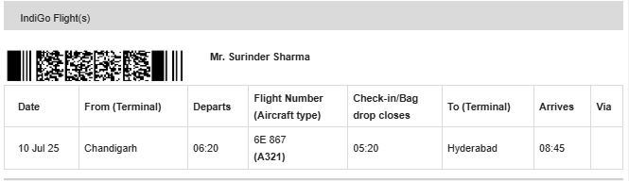

**Contact Information**

**Traveler Details**

**NAME SURNAME EMAIL ID PHONE NUMBER**

|  |  |  |  |
| --- | --- | --- | --- |
| SURINDER | SHARMA | Zest2914@gmail.com | 8054228637 |
|  |  |  |  |





# **Term & Conditions**

**Purpose of the Dummy Tickets:** The Dummy Ticket you get from Travanya can only be used to demonstrate that you intend to apply for a visa. We do not represent at any point in time that the Dummy Tickets issued by Travanya fulfill the required criterion for a visa application or that you will necessarily secure a Visa by using the Dummy Ticket. The Dummy Tickets issued by Travanya cannot be used for your actual travel or to go on a flight trip and can be neither presented as valid tickets at the airport for air travel. By using our Website and booking a Dummy Ticket you explicitly acknowledge and comprehend the distinction between a Dummy Ticket and a confirmed ticket. You hereby agree that you shall be solely liable and responsible for all and/or any liability that may accrue for purporting to use the Dummy Ticket for actual air travel or for tampering or altering any contents of the Dummy Ticket for securing visa, or any purpose whatsoever.

**Provide Correct Information:** When you book a Dummy Ticket, you shall make sure to give the correct details like your name, passport information, and travel dates. The details provided by you to us at the time of booking Dummy Tickets should match with the information mentioned in your visa application. You consent to solely bear all/any liability arising from any false, or incorrect information that you provide to us or if you provide to us any such information which is materially different from the information submitted by you for the purpose of your visa.

**Possible Delays:** While Travanya tries its best to give you the Dummy Ticket upon successful booking within the committed time, there might be delays due to technical glitches, technical errors/issues, or other reasons. We do not accept any responsibility for any failure in bookings, payment gateway failures, or for all/any reasons that are beyond our control. Travanya is not responsible for any delays in the booking of tickets.

**Acceptance of Dummy Ticket:** Travanya cannot guarantee that the Dummy Ticket will be accepted by any authority or embassy. It's the user's responsibility to check the visa application requirements.

Travanya does not have any responsibility if your visa gets rejected for any reason. You agree that your purchase of the Dummy Tickets from Travanya is at your own risk and we do not assure or guarantee you that the Dummy Ticket issued by Travanya will help you in securing your Visa or will actually serve your purpose.

**Dummy Ticket is not for Actual Travel:** Even though the Dummy Ticket may look real, remember it's not for actual travel or bookings. Avoid showing it to airlines, immigration officers, or anyone else involved

in travel matters. You understand and agree that at no point in time, we represent that the Dummy Tickets are real travel tickets or confirmed tickets or they will help you obtain a visa, or will necessarily serve the purpose for which it is /they may be presented. You consent to any and all liability that may arise if you attempt or intend to treat such Dummy Tickets as actual/confirmed tickets before visa authorities, airport authorities, or official authorities.

Thank you for choosing [travanya.com](https://www.travanya.com/) for your dummy flight ticket.