

Self-Declaration

Date: 10 Dec 24

Sub- Declaration regarding TCS

I / We understand that:

1. For purchase of overseas tour program package under clause (ii) of sub-section (1G) of section 206C, the TCS shall continue to apply at the rate of 5%.
2. This package includes, 5% TCS and I have not exhausted the individual limit of 7 lakhs in this financial year as on date.
3. If any claim of TCS amount arises in future even after my self - declaration then I am liable to pay the extra amount (as per 20% TCS rate).
4. I/We authorize Shipra Travels Pvt Ltd to collect TCS and deposit as per the below mentioned Pan card details shared.

Name of Pax: Niraj Rajesh Somani

Pan No: KXGPS6647C

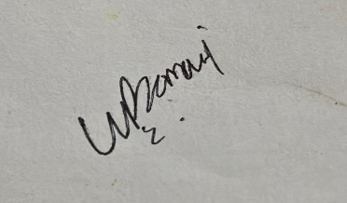

Signature