**Dear Sir/Ma’am,**

Greetings from Travanya Holidays Venture of Shipra Travels.

Thank you for giving us the opportunity to let us plan your holidays. Over the years, we have given an extra effort to maintain the customer service and managed to get 99% of our repeat customer to again book their holiday from us. With this promise, we assure you to make your holiday an unparalleled experience. We hope you enjoy your Holiday as much as we enjoyed bringing it to you.

Kindly check and confirm following details and revert on the same.

# Travel Details: -

|  |  |
| --- | --- |
| **Destination** | **Thailand Holiday Package** |
| **Duration** | 05 Nights / 06 Days |
| **No. of People** | 03 Adults |
| **Date** | 07th July 2024 to 12th July 2024 |

# Flight Details: -

# Total Flight Fare: @INR 18,800 per person

# 

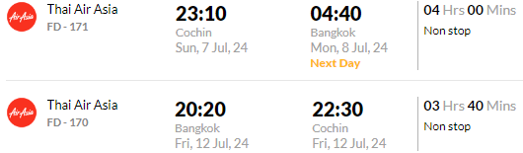

**Hotel and Sightseeing Details: -**

# Option 01: -

**Only Land Package cost:** - **@INR 22,300/-** Per Person with **3\*** accommodation

|  |  |  |  |  |
| --- | --- | --- | --- | --- |
| **Destination** | **Hotel** | **Rooming** | **No. of Nights** | **Meal Plan** |
| Pattaya | Golden Tulip Essential Pattaya | Superior Room | 03 Nights  02 Rooms | Breakfast |
| Bangkok | Anya Nana @ Sukhumvit | Superior Room | 02 Nights 02 Rooms | Breakfast |

## Package Inclusions: -

* **03 nights’** accommodation with above mentioned hotels at Pattaya
* **02-night** accommodation with above mentioned hotels at Bangkok
* Daily Breakfast
* Return airport transfers – PVT
* Alcazar Show
* Coral island Tour Pattaya with lunch on Speed Boat Sic
* Nongnooch village + lunch + show sic
* Safari world with marine park with lunch Sic (Monday Closed)
* Bangkok City Tour
* TCS 5% included
* All transfer on private basis and sightseeing on SIC basis

# *Transfer*

01 Way Taxi from DMK Airport to Pattaya Hotel

01 Way Taxi from Pattaya Hotel to Bangkok Hotel on Route City tour

01 Way Taxi from Bangkok Hotel to DMK Airport

## Exclusions: -

* Any Kind of Personal Expenses or Optional Tours / Extra Meals Ordered
* Services of local tour guide.
* Anything not specifically mentioned under the head “Inclusions”.
* Tips, Insurance, Laundry, Phone Calls.
* Any kind of drinks (Alcohol, Aerated)

***Note:*** *The flight fare and land package cost is separate and is subject to availability*

# Tentative Itinerary: -

**Day 01:** Arrival Transfer from DMK APT – Pattaya HTL + Alcazar show

**Day 02:** Coral island Tour Pattaya with lunch on Speed Boat Sic

**Day 03:** Nongnooch Village + lunch + show Sic (Pattaya)

**Day 04:** Safari world with marine park with lunch Sic (Monday Closed)

**Day 05:** Transfer from Pattaya HTL-BKK HTL + Bangkok City Tour

**Day 06:** Departure transfer from Bangkok Hotel – DMK APT

## Payment Policy

|  |  |
| --- | --- |
| 60+ Days from DOT - | Non-refundable component + 25% of land package |
| 45 to 60 Days from DOT - | Non-refundable component + 50% of land package |
| 30 to 45 Days from DOT - | Non-refundable component + 80% of land package |
| 30 days from DOT - | 100% of Package Cost |

***Note:*** *Full payment of Flight ticket is required before issuance*

**Payment Link**<https://www.travanya.com/make-payment/>

# Bank Details

|  |  |
| --- | --- |
| **Bank Name** | **HDFC Bank LTD** |
| **Account No** | 59210000002222 |
| **Name** | SHIPRA TRAVELS PVT LTD |
| **IFSC CODE** | HDFC0001321 |
| **Branch** | SWASTIK VIHAR, Panchkula |

## Cancellation Policy

|  |  |
| --- | --- |
| 30+ Days from DOT - | Non-refundable Component |
| 30 to 15 Days from DOT - | Non-refundable component + 50% of land package |
| 15 to 7 Days from DOT - | Non-refundable component + 75% of land package |
| 15 days from DOT - | 100% of Package Cost |

***Note:*** *Travel Insurance is non-refundable after issuance*

# Terms & Conditions

* Passport of all the passengers is required at the time of booking.
* Passport should be valid at-least 6 months from your return date.
* PAN card is mandatory for International Travel.
* No Bookings are made at the time of Quotation.
* Token amount is always non-refundable.
* Hotels and Services as mentioned above are subject to confirmation.
* Any Additional Tax of the respective Country, city, sightseeing is to be paid by customer directly.
* Standard Check in Time is 1400 hrs and Check out is 1200 hrs.
* Early Check-in & late check out is chargeable. Complimentary early check-in and late checkout is subject to availability.
* Any Change in VISA fees, Policies and Govt. taxes will be levied before departure date.
* Addition of Any services on ground directly by the customer will not be responsibility of Travanya.
* Any Tip for any service is to be paid directly by customer that cannot be a part of package
* We should not be held responsible for acceptance and rejection of VISA. Its sound decision concerned Embassy
* Any sudden rise in Airfare, Hotel rates & other ground service charges should be borne by customer.
* GST & TCS of 5% each is required if payment is in INR currency and for other currency ROE is calculated as per Date of payment.
* Travanya should not be held responsible for any cancellation and changes due to any natural

Calamity.



**Option 01: - With the transit time of 9h 15m**

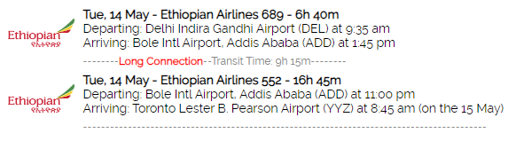

Option 02: - Direct Flight (1,46,675)



Option 03: - Transit time 15h 20m (1,30,118)

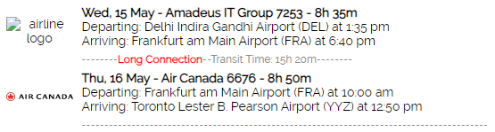

Option 04: - Transit time 3h 35m (1,43,339)

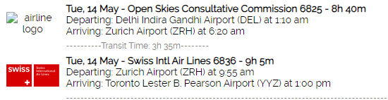

Option 05: - transit time (1h 15m) 1,36,279

