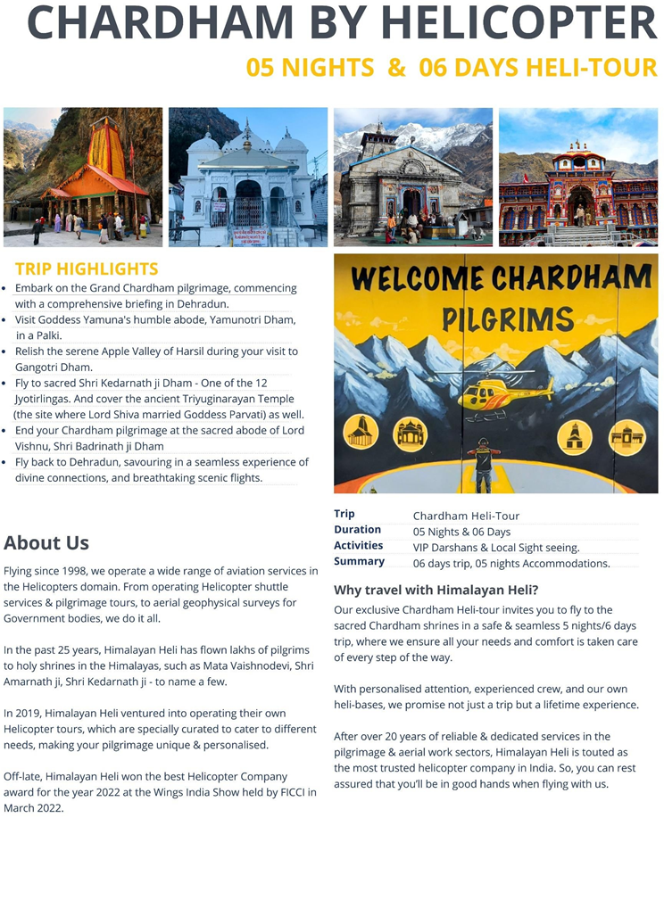



**OUR CHARDHAM PACKAGE**

# CHARDHAM BY HELICOPTER: 5N/6D Heli-Tour

***Dehradun - Yamunotri – Gangotri – Kedarnath – Badrinath***

W a rm greetings from Himalayan Heli!

Flying with expertise, care & love since 1998, we take immense pride in saying that we have touched the hearts of thousands of pilgrims by our hospitality & helicopter services since the past two decades.

And after years of dedicated services, we are touted as **India’s leading helicopter**

**company in pilgrimage tourism.**

**The Chardham yatra** - Comprising four abodes: Yamunotri, Gangotri, Kedarnath & Badrinath, is certainly, an extensive pilgrimage but needless to say, it’s worth it. For both your soul and eyes.

Understanding the importance of this yatra, we offer a specially curated, safe and mesmerising Heli-Tour.

With us - Your itinerary, safety and privacy are all sorted out.



# OUR PACKAGE INCLUSIONS

* Helicopter flying from Dehradun to the Chardham shrines, & back.
* **Accommodation @ Dehradun on the Arrival Day**, just to unwind & get ready for your Chardham Yatra. Only Dinner & breakfast included on the first night.
* Accommodation for 5 nights: Accommodation at Dehradun on MAP Basis, and 01 night at each Dham with all meals included.
* Vegetarian Jain food is available at the hotels.
* Local Sight Seeing with Himalayan Heli guides at all four destinations.
* VIP Darshans.
* Airport & hotel transfers at Dehradun.
* Palki or Pony at Yamunotri - subject to availability.
* Shri Kedarnath ji helicopter shuttle services: Sersi – Kedar - Sersi.
* Local transportation at all the Dhams.
* Taxes & other government levy.

*In short* ***– We have included every little detail, comfort & charge*** *that you will encounter on your Chardham yatra. Therefore, by taking a one-time wholesome charge, you enrol yourself*

*on this journey of a lifetime.*



# ADD- ON SERVICES:

Our team can arrange any extra inclusion that you may want on your tour, such as:

*Air tickets, Haridwar or Rishikesh visit, hotel bookings for extra night halt, Special pujas, etc.*

Confirmation against the same must be given in advance.

# SPECIAL RECOMMENDATION:

**Stay @ Six Senses Vana, Dehradun: Vana is India’s top wellness retreat.** Situated at the Himalayan foothills in Dehradun, this resort is surrounded by lush green forest.

This place offers a wide range of ancient healing therapies, such as Ayurveda, Yoga,

Tibetan Medicine, Sound Therapy, and Natural Healing Therapies, ensuring a **comprehensive & transformative wellness journey.**

Your stay will be inclusive of 01 Ayurvedic/Tibetan/natural healing therapy per day, and all resort activities such as Hatha Yoga, nature walks, Raag therapy, etc. It is suggested to spend

minimum 3 nights at this dreamlike retreat, after the end of your pilgrimage, for a **perfect spiritual experience.**

**Minimum 03 nights** stay is mandatory**.**

**Price** - On Request.



**CONFIRMATION AGAINST THE ADD-ON SERVICES MUST BE GIVEN IN ADVANCE.**



# TOUR GUIDELINES:

* **VIP Darshans** are subject to the orders issued by the temple authorities and State government.
* In view of our helicopters’ weight-carrying capacity, **Himalayan Heli reserves the right to shuffle passengers between helicopters to manage the right weight for safe flying in the hills.** Therefore, passengers travelling together may not be accommodated in the same helicopter flight.
* **FIXED FLIGHT TIMINGS**: This is a **Daily Fixed Departure Helicopter tour**, and departure timings of each destination is fixed. Therefore, passengers must ensure they report as per the scheduled ETDs. However, Himalayan Heli reserves the right to change/postpone the timings of flying one day prior, subject to weather/force majeure reasons.
* Passengers must **submit their correct weights at the time of booking**. Submitting incorrect weights may lead to passengers being debarred from boarding without any refunds.
* **BAGGAGE ALLOWANCE**: Only one baggage weighing a maximum of 5 kgs is allowed per passenger. It Is not permitted to carry suitcases or big travel bags in the helicopter; therefore, **duffle bags will be provided by our team to all passengers on the day of arrival**.
* Arrival/departure details must be provided at the time of booking so that we can smoothly operate the tour.
* Passengers should book Dehradun arrival flights reaching around 02:00 pm, or earlier.
* Kedarnath shuttle service: Passengers will be ferried to Kedarnath ji in a shuttle services flight. And it is likely that passengers travelling together may not be accommodated on the same flight.
* Any sudden increase in taxes/levy by the State Government or the temple authorities, will be borne by the passengers.
* If online yatra registration will be compulsory, then passengers will have to do the same prior to travel.
* Comfortable clothing such as tracksuits or Kurtas are advised on the tour. As for shoes, one should carry sports or trekking shoes.
* Himalayan Heli has its own crew at all the Dhams. For assistance, they will be with the passengers always.
* Infants below 2 years (Max 12 kg weight) are accommodated free of charge. For verification of age the child, ID proof/birth certificate of the child will be checked.
* In case an infant is on board, the weight of the infant will reduce the total permissible weight of that respective group.
* Any donations, tips, pitthu, extra porter charges shall be borne by the passengers.
* Airport transfers shall be provided on the arrival day at Dehradun, and on the last day of our tour.
* Airport transfer shall be provided on the arrival day or maximum one day prior to the arrival day, and the same would be applicable for the drop at Dehradun Airport. Only 01 transfer would be provided for each side.
* Network connectivity at Harsil & Badrinath is very poor. BSNL, Airtel & Jio are the main telecom services, that work in these regions mostly.
* All temples in Chardham sector are located at a high altitude, therefore passengers are advised to **carry medication** during travel. Also, they are advised to carry warm clothing with them, because during evenings & nights, the temperature can drop drastically.
* For the senior citizens and people with medical issues are hereby advised to kindly consult a doctor and get medical check-up done before commencing the yatra. Medical check-up is mainly required if a passenger has any medical ailment.



# CHARDHAM ITINERARY

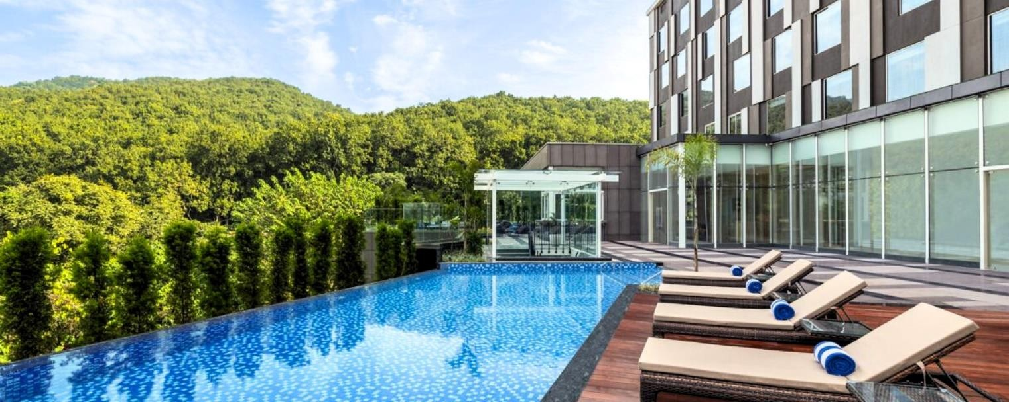

**DAY 01: DEHRADUN**

* Day 01: This is the reporting day at Dehradun, which is our main base (starting & ending point) for the Heli-tour.
* Himalayan Heli arranges this extra night halt for the passengers, which is inclusive of dinner and breakfast, to wind down and be fully ready for the journey ahead.
* Passengers will be picked up from Dehradun Airport/railway station/bus stand according to their arrival timings.
* In the evening, there will be a **Tour Briefing (mandatory to attend) by our Dehradun team**, which will be conducted at **1900 Hrs**. Duffel bags will be provided during the tour briefing, in which necessary luggage will have to be packed by the passengers – Maximum 5 kg/person will be permitted.

**Please note: Our staff will be taking the body weight of each pilgrim during the tour briefing; hence kindly ensure you attend the same.**

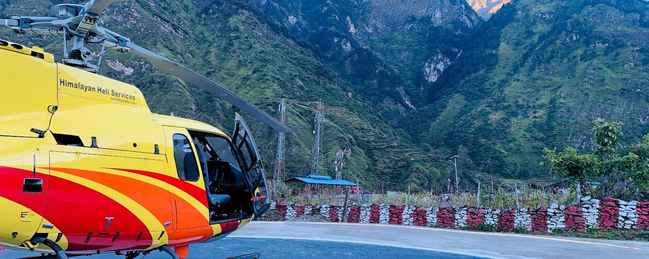

**DAY 02: YAMUNOTRI DHAM**

**Sahastradhara to Yamunotri**

|  |  |
| --- | --- |
| **0630 Hrs** | **Check out from Dehradun hotel** |
| **0730 Hrs** | **ETD from Sahastradhara Helidrome** |
| **0800 Hrs** | **ETA at Kharsali Helipad** |

* This is the starting day of the Chardham yatra. Passengers will check-out from the hotel at 06:30 am, after an early morning breakfast. They will be picked-up from the Hotel by our team & taken to Sahastradhara Helidrome.
* **Himalayan Heli has its own Heli-base in Kharsali**, where our ground staff would welcome the passengers. The staff will then get the passengers settled in the hotel, which is at a walking distance from the helipad.
* After reaching the hotel, the passengers will be taken for darshan as soon as possible, to avoid the yatra rush.
* **Approximate time taken for Yamunotri Temple Darshan:** Approximately 05hrs 30mins (round-trip). Yamunotri trek is 06 km one-way.
* **Sightseeing at Kharsali:** Hot Spring at Yamunotri Temple, Yamuna Mata Temple, and Shani Temple.

**Please Note: Since, Kharsali village is the least developed destination among the Chardhams. Hotel accommodation will be basic.**

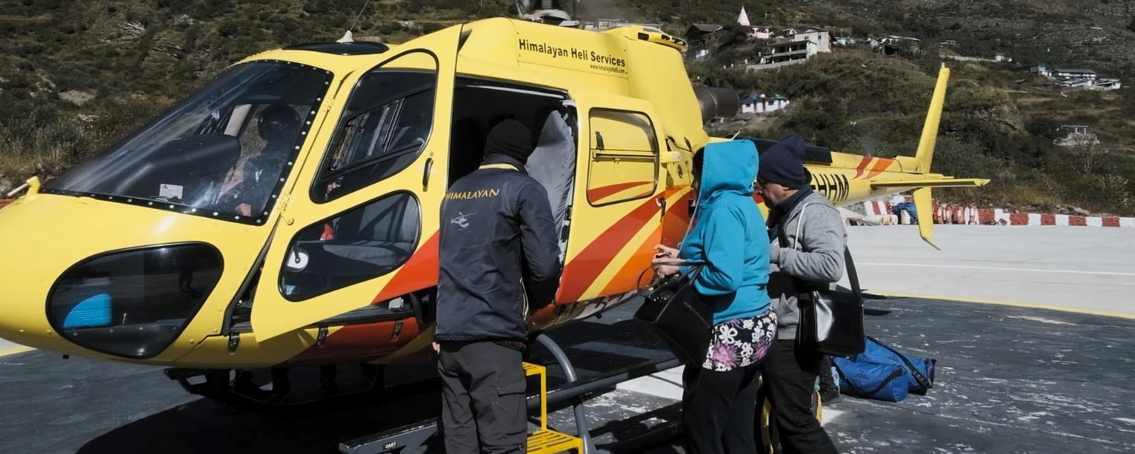

**DAY 03: GANGOTRI DHAM**

**Yamunotri to Gangotri**

|  |  |
| --- | --- |
| **0800 Hrs** | **ETD from Kharsali Heli-Base** |
| **0830 Hrs** | **ETA at Jhalla/ Harsil Helipad** |

* After breakfast, passengers will check-out by 0730 hrs.
* Arrival at Jhalla helipad will at 0830 Hrs.
* **Jhalla – Himalayan Heli’s second own Heli-base** in the Chardham sector. After landing at Jhalla, passengers will be taken to Harsil village & checked-in the hotel.
* **Harsil** – The second destination of our tour, also known for the abundant apple orchards there, is the most scenic and beautiful destination of this tour.
* Passengers will be taken for Gangotri Dham darshan before or after lunch – Depending on rush.
* **Approximate Time taken for Gangotri Temple Darshan:** 3hrs 30 mins (round-trip). The road distance to Gangotri temple is approx. 25 km, which is roughly a 50-minute drive.
* **Sightseeing at Harsil:** Bagodi Village / Ancient Laxmi Narayan Temple in Harsil. Other than this, Harsil also has many nearby nature-walks to explore.

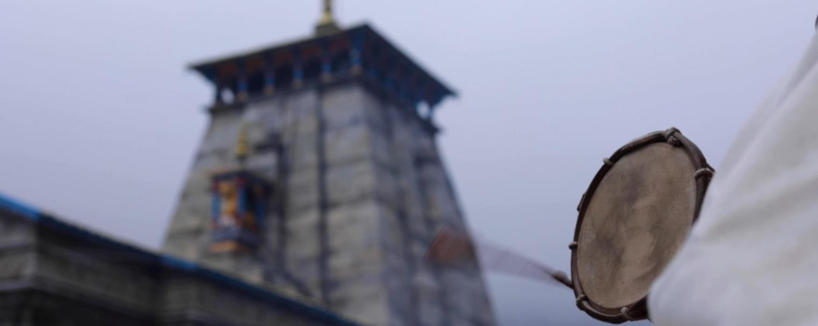

**DAY 04: KEDARNATH DHAM**

**Gangotri to Sersi**

|  |  |
| --- | --- |
| **0830 Hrs** | **ETD from Jhalla/ Harsil Helipad** |
| **0900 Hrs** | **ETA at Sersi Heli-Base** |

* After breakfast, passengers will check-out by 0730 hrs.
* Arrival at Sersi Heli-base will be at 0900 Hrs.
* **Sersi – Himalayan Heli’s third, and the oldest, own Heli-base** in the Chardham sector.

We operate the shuttle services for Kedarnath ji shrine from here.

## Passengers will be ferried to Kedarnath Dham for darshan in a shuttle services flight.

* **Approximate time taken for Kedarnath Temple Darshan:** 02 hours.
* The shuttle services flight Sersi to Kedarnath is apporx. 07 minutes long.
* Passengers might be ferried in different shuttle services flights, in view of the maximum weight carrying capacity of the aircraft at a high-altitude destination such as Kedarnath.
* **Sightseeing at Sersi:** Triyuginarayan Temple – It is the venue of the celestial marriage of Lord Shiva & Goddess Parvati. **(Subject to weather and road traffic conditions).**

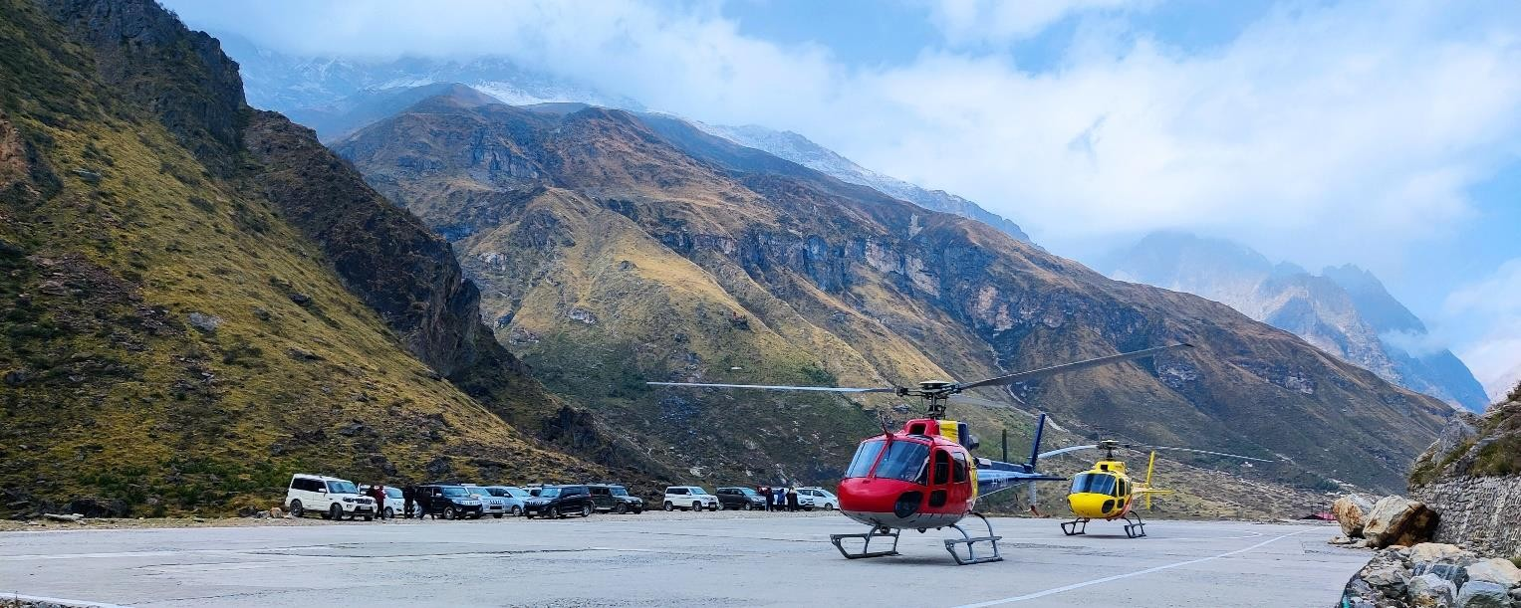

**DAY 05: BADRINATH DHAM**

**Sersi to Badrinath**

|  |  |
| --- | --- |
| **0600 Hrs** | **ETD from Sersi Heli-Base** |
| **0630 Hrs** | **ETA at Badrinath Helipad** |

* Passengers will check-out by 0500/0530 Hrs.
* Arrival at Badrinath will be 0630 hrs.
* Passenger will first check-in to the hotel and have breakfast. Darshan and sight-seeing will be done after breakfast or lunch – Depending on rush.
* **Approximate time taken for Badrinath Temple Darshan:** Approx. 01-1.5 Hrs.

Passengers will be taken from hotel to the temple by car.

* **Sightseeing at Badrinath:** Mana Village – Known as the ‘First village of India’, due to its

proximity to the China border.

* **Aarti / special pooja at Badrinath Temple – Swaran/Chandi Aarti (on an additional direct payment basis at Badrinath), with extra vehicle charges.**

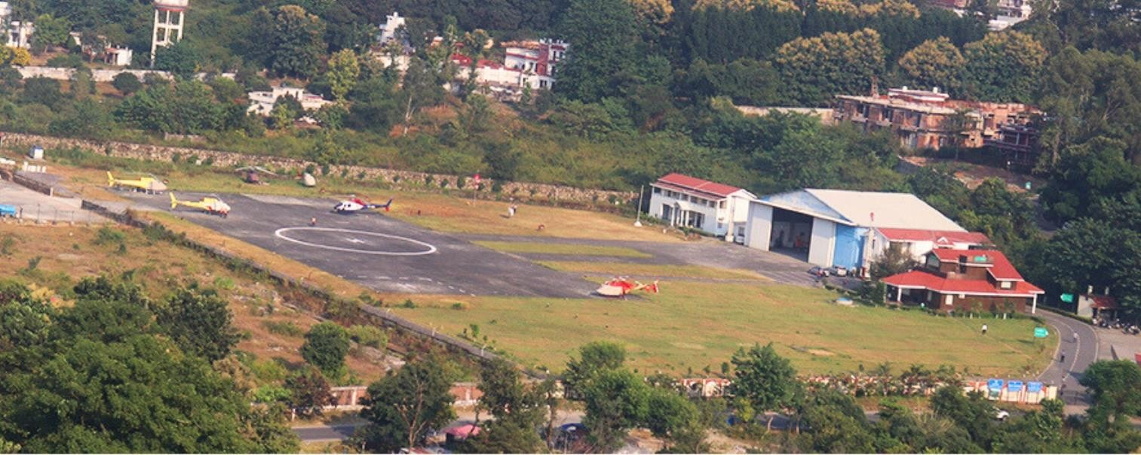

**DAY 06: RETURN TO DEHRADUN**

**Badrinath to Sahastradhara**

|  |  |
| --- | --- |
| **0630 Hrs** | **ETD from Badrinath Helipad** |
| **0730 Hrs** | **ETA at Sahastradhara Helidrome** |

* Passengers will check-out by 0530/0545 Hrs.
* On arrival, our team will receive the passengers.
* Then passengers will be taken to the Dehradun hotel to collect their luggage from cloak rooms, and then have breakfast.
* Later they’ll be dropped to airport/railway station, where we bid farewell to the passengers.

*This is the end of the Chardham yatra.*



# TERMS AND CONDITIONS

## COVID TRAVEL GUIDELINES

COVID protocols must be adhered by the passengers as per the effective mandate of the government. Without adhering to the government guidelines, boarding shall be denied to the passengers without refund.

## SEATING CAPACITY

The seating capacity of our helicopter is 06 passengers.

## HELICOPTER WEIGHT LIMITATION

Maximum weight weight capacity of the helicopter is **450 kg** (excluding baggage weight). Passengers are taken on board depending on the load and temperature conditions, and the pilot's call will be final. Hence, passengers are required to provide us with their exact body weights at the time of booking.

Exceedance of helicopter weight carrying capacity will result in passengers getting deboarded and cancelled for the Heli-tour without any refund.

## OVERWEIGHT CHARGES

Overweight charges are applicable @ **INR 2,000/kg**. This will be chargeable to passengers weighing **above 75 kg.** But excess weight will only be calculated on the total excess weight above the total permissible weight of all the group members combined, i.e., permissible weight = 75 Kg x (No. of pax).

Any discrepancy found in the weights of the passengers, which will be chargeable as per the overweight criteria, the same would be collected prior to boarding of flights.

Please Note: While submitting the body weights, please keep in view that you submit your final weight on the higher side, after adding extra weight of your clothes and shoes.

## ARRIVAL DATE

Our Chardham 5N/6D Heli-tours are booked flying-date-wise (Day 02 of the tour). Passengers must report to Dehradun one day prior to the flying date.

## BAD WEATHER & FORCE MAJEURE DISCLAIMER

Flying in hills is subject to bad weather, and many Force Majeure factors like delayed Air Traffic Clearances/Permissions, VVIP movements, valley flying by Indian Air Force (NOTAM), sudden occurrence of technical snag in aircraft, illness of flying crew or late reporting of the passengers at the helipads, among others.

Therefore, passengers must be prepared to face any eventuality and inconvenience in case of such scenarios.

* **AADHAR Card** copies are to be shared by all Indian passengers, & passport in case of foreign nationals.

## HOTELS:

* + **DEHRADUN :** Fairfield by Marriott, or similar (MAP basis – Dinner & Breakfast).
  + **KHARSALI :** Hotel Holy Yamuna, or similar (AP basis - all meals)
  + **HARSIL :** Harsil Retreat, or similar (AP basis - all meals)
  + **SERSI :** Ghughuti Resort, or similar (AP basis - all meals)
  + **BADRINATH :** Hotel Vijay Lords, or similar (AP basis - all meals)
* Hotels are subject to sudden change.
* Rooms are booked on double or triple sharing basis only.
* For a separate **single occupancy room**, it will be extra chargeable @ **INR 45,000/person (tax inclusive**).
* Hotels at all the Dhams are non-star category. However, we have carefully selected the most comfortable properties for our Heli-tours.
* We advise our passengers to **keep one additional day at hand at the end of the tour,** over & above the 5N/6D period, to avoid missing their return flights in case they get stuck at any of the destinations due to bad weather or force majeure reasons.

## ADD-ON SERVICES

Additional services which are not mentioned in our inclusions will be extra chargeable, and the same must be confirmed to us at the time of booking.

## ACCOMMODATION AT KEDARNATH TOP:

Accommodation at Kedarnath Top can be booked for the pilgrims. However, Himalayan Heli do not advise pilgrims to stay overnight at Kedarnath Top, due to high altitude sickness and lack of basic facilities such as Hot water, Heater & and medical assistance.

Price - On Request

## MEDICAL EMERGENCIES

Himalayan Heli will not be liable for any medical emergency on the ground to the passengers. Therefore, in your own interest, passengers are hereby advised to kindly consult a doctor andget medical check-up done before commencing the yatra.

Medical check-up is mainly required if a passenger has any medical ailment or condition.

If Medical evacuation by Helicopter is needed, it will be chargeable @ INR 1,20,000/ Hr + UCADA royalty & landing charges + GST.

## CARRIAGE BY AIR ACT, 1972

The carriage is subject to Himalayan Heli Services regulations relating to the conditions of Non-International Carriage (Passenger and Baggage) framed in accordance with The Carriage by Air Act, 1972 and Notification regarding application of the carriage which is non-international. The liability of the company for damage sustained in the event of the death or wounding of a passenger or any other bodily injury suffered by passenger or by his registered baggage during the course of carriage by air will be governed by the provisions of sections 4,5,6 and the rules contained in the second Schedule of Carriage by Air Act 1972 with certain exceptions, adaptations, modifications, etc as notified in the Govt. of India, Ministry of Civil Aviation Notification and as amended from time to time.

* Himalayan Heli reserves the right to cancel passengers, who are unruly, abusive, intoxicated, sick, mentally unfit or anyone else whom we deem to be unsafe to fly. No refund shall be done to such passenger(s).

## Our Heli-Tours are not available for the following VIP’s:

* Speaker Lok Sabha
* Dy. Chairperson Rajya Sabha
* Central Ministers of Cabinet Rank
* C J I Supreme Court
* Governors of State
* Chief Ministers of State
* State Ministers of Cabinet Rank
* SPG Protectees – Z category only.

## RESCHEDULING OF BOOKING

Rescheduling your booking to any future or prior travel date, will be done subject to availability, and on payment of 10% of the total tour cost. This will be permitted only if informed at least 28 days before arrival date. In case rescheduling is requested less than 28 days prior to the travel date, then the booking would be treated as cancelled, & and a fresh booking will be given subject to availability, after the levy of applicable cancellation charges.

## PAYMENT TERMS:

* We accept payments via bank transfers, cheques, cash, UPI and card machine.
* The booking is to be done in advance with a deposit of 50% of the total amount. Balance payment will be taken 14 days prior to the date of arrival at Dehradun.
* Passengers will not be permitted to board or commence the tour, unless full & final payment of the tour has been done.
* Payments via credit/debit card machine will incur 3.5% extra charge.
* Payment via American Express / Foreign cards will incur 4.5% extra charge.

## CANCELLATIONS POLICY:

If passengers cancel their booking, following cancellation charges will be applicable –

* More than 25 days prior to travel date: 30% of total tour cost.
* More than15 to 25 days prior to travel date: 50% of total tour cost.
* 14 - 08 days prior to travel date: 75% of total tour cost.
* 07 Days or less prior to travel date: No Refund
* No show: No Refund.
* After commencement of the tour: No Refund.
* **FORCE MAJEURE & BAD WEATHER REFUNDS**: Basis of Refund:
* Tour Cost: The refundable amount of each uncovered Dham will be as mentioned below:
* Kharsali/Yamunotri: 20% tour cost minus INR 30,000 towards Flight preparation charges and utilized services (if any).
* Jhalla/Gangotri: 25% tour cost minus INR 30,000 towards Flight preparation & service charges, and utilized services (if any).
* Sersi/Kedarnath: 25% tour cost minus INR 30,000 towards Flight preparation & service charges, and utilized services (if any).
* Badrinath: 30% tour cost minus INR 30,000 towards Flight preparation & service charges, and utilized services (if any).
* Full tour cancellation: Full refund minus INR 30,000 towards flight preparation, hotel retention charges and utilized services (if any).
* Additional Services: The cost of additional services provided at any Dham during the tour will be deducted over & above the refundable Tour Cost.
* Refund against an unutilized service will not be done.
* COVID-19 Lockdowns, or any National/State Emergency:

In case passengers test COVID positive before the travel, or the Yatra gets called-off by the government, or any National or State emergency is imposed, there will be **no refunds applicable**.

However, passengers will be provided a Credit Voucher by Himalayan Heli against the advance paid, which will be valid for one year. It can be utilized against any of our helicopter tours or charter services by the passengers or any of their friends/relatives.

## BAD WEATHER & FORCE MAJEURE POLICIES:

* Where bad weather, technical snags, or any force majeure reason beyond Himalayan Heli Services’ control results in the cancellation of the flight or delay, Himalayan Heli Services will not be liable in any way for the cancelled or delayed flight. However, refund will be given to clients as per our refunds policy. Any kind of inconvenience caused because of

cancellation of flights is beyond the control of the operator. No compensation or reimbursement for accommodation, transportation, meals, or any other extra travel expenses done by the passengers shall be offered in the event of cancellation of a flight.

* In case tour departure does not take place from Dehradun on Day One due to above reasons, tour will be considered as cancelled and full refund as per our policies will be made. However, incase the passengers would like to consider taking the tour on the next available date, a fresh booking can be made for the same. Our team will propose the available options to the passengers.

The balance/unutilized amount against previous booking can be adjusted against the fresh booking. And any extra costs that would be accruing, will have to be borne by the passengers.

* In case the tour departs from Dehradun as per schedule but gets disrupted, while the tour is ongoing, our team will propose the possible revised itinerary within the scheduled package days, but without any extension of days.
* Any extension, proposed by the passengers, in the package will only be considered at an extracost and subject to operational viability.
* In case for 05 straight days flying does not take place, full refund as per our policies will be made to the passengers.
* New Chardham passenger(s) scheduled for departure from Dehradun on any respective travel date shall be our top priority, over the back-log passenger(s) of previous days(s).
* In case of passenger get stuck at Kedarnath top due to bad weather or Force Majeure, the accommodation charges at Kedarnath will borne by the client directly.
* Additional night halt charges will be payable by the passengers to hotels on direct payment basis if they get stuck for additional nights due to bad weather/force majeure reasons over and above the 5N/6D period.
* If passengers require extra helicopter flying at the end of their tour, the same will be chargeable at INR 1,20,000/Hr + UCADA royalty & landing charges + GST.
* Himalayan Heli may not fly to Harsil/Jhalla, in case of turbulent wind conditions – which is common in the Harsil valley after 1200 Hrs.
* While the tour is ongoing, if any group demands to cancel their tour mid-way, the arrangementof transportation will be done by Himalayan Heli, however, cost for the same will be borne bythe passengers on direct payment basis.
* Any increase in government levies or taxes, after the confirmation of booking, will be extra chargeable to the passengers. Payment against the same will have to be done before the commencement of tour.

## DISPUTES

Disputes as to legality, interpretation, application or performance of service or any of its terms and conditions shall be governed by the laws of Delhi Jurisdiction.

* Bookings will be taken, considering there is acceptance of the above-mentioned terms & conditions by the party.

**W E ASSU RE YO U O F A SAF E & ME MO RABL E PILG R IMAGE**