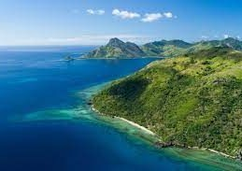



 **Fiji 5 nights**

 **03 Feb 2025 - 5 nights/6 days**

 **1 room, 2 adults**



# Itinerary

**Fiji 5 nights**





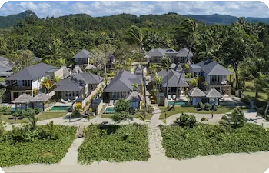**Nanuku Resort Fiji**

11 Nanuku Drive

### Exceptional

9.4

63 ratings

Check-in

**02:00 PM Mon, 03 Feb**

VIEW

Check-out

**11:00 AM Sat, 08 Feb**

 1 x Nanuku Suite

1 King Bed and 1 Twin Sofa Bed, Free breakfast, Free valet parking, Free self parking, Free WiFi, Save10%

Meals included - Breakfast

Fully refundable before 20 Jan

Arrival at Fiji Mon, 03 Feb, 2025

Day 1

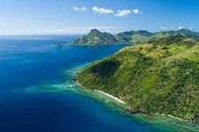



**Notes:**

Airport to Hotel Transfer with Tewaka.

On arrival proceed through the airport immigration and customs hall, once cleared our airport representative will be waiting to welcome you.

If you need to contact your transfer, please call : +679 9959 170 between 8am - 5pm and +679 8921 611 after hours.

 Overnight stay at Nanuku Resort Fiji

 Lunch

Not Included

 Dinner

Not Included

Fiji - Day at leisure Tue, 04 Feb, 2025 - Fri, 07 Feb, 2025

Day 2 - 5

Today you are free to relax or explore your resort and the surrounding area on your own. Overnight stay at hotel.

 Overnight stay at Nanuku Resort Fiji  Breakfast

Included at Hotel

 Lunch

Not Included

 Dinner

Not Included

Departure from Fiji Sat, 08 Feb, 2025

Day 6





**Notes:**

Hotel to Airport Transfer with Tewaka.

Please reconfirm your pick-up time with Tewaka at least 24 hours before departure. If you need to contact your transfer, please call: +679 9959 170 between 8am - 5pm and +679 8921 611 after hours.

 Breakfast Included at Hotel

 Lunch

Not Included

 Dinner

Not Included

# Inclusions

### Fiji 5 nights - Mon, 03 Feb



Stay for 5 nights at Nanuku Resort Fiji

1 x Nanuku Suite

1 King Bed and 1 Twin Sofa Bed, Free breakfast, Free valet parking, Free self parking, Free WiFi, Save10%

One way transfer from Airport to Hotel - Private Transfers from Nadi Airport to Pacific Harbour Day 1

Private Transfers

Mon, 03 Feb, 2025

One way transfer from Hotel to Airport - Private Transfers from Pacific Harbour to Nadi Airport Day 6

Private Transfers

Sat, 08 Feb, 2025

### Breakfast

**Included on 5 days**

### Lunch

Not Included

### Dinner

Not Included

## Exclusions

Passport fees, immunisation costs, city taxes at the hotel and local departure taxes (wherever applicable) Optional enhancements like room or flight upgrades, or local camera or video fees

Additional sightseeing, activities and experiences outside of the itinerary Early check-in or late check-out from hotels (unless otherwise specified)

Breakfast, lunches, dinners and drinks (alcoholic and non-alcoholic), unless specified in the itinerary Any international and/or domestic flights, unless explicitly mentioned as an inclusion

Excess baggage charges, and where applicable, baggage not included in your fare Tips for services and experiences

Any Visa required, unless mentioned as an inclusion

Read useful information and terms for more on what is included and excluded

## Any Other Commitments

If any other service or commitments have been made apart from the inclusions in the proposal, then please make sure they are mentioned in this section.

**Price Breakdown**

1 room, 2 adults Nationality: India

Departure City: Fuzhou

Price per adult AU$ 1,795

Total Price

INCLUDING ALL TAXES

**AU$ 4,589**



Total price as calculated on 04 Sep, 2024 at 03:18 PM DAVT Price subject to availability

 **Important Notes**

**Oceania**

**General**

#### Please note all shared sightseeing tours in Australia and New Zealand are operated by 3rd party operators. In case a tour is canceled by a operator for any reason, we shall be liable to issue a full refund against it. Any changes or alternate tours or private upgrades will attract extra charges.

**General**

1. Any ticket to attractions, museums, train, cable car, ferries, rides, safari, etc. are not included unless explicitly mentioned as an inclusion.
2. For queries regarding cancellations and refunds, please refer to our Cancellation Policy.
3. We reserve the right to issue a full refund in case we believe that we are unable to fulfil the services for any technical reasons.
4. Please make sure that the passport of all guests travelling is valid for at least 6 months from the date of travel.
5. We can only facilitate the visa application for the travelling passengers. Granting of visa is solely at the

discretion of Embassy. If visa is rejected or delayed by the Embassy for any reason then we are not liable to give any refund and respective cancellation policies will apply.

**Hotel**

1. At the time of check-in to your hotel, hotel may ask you to make an advance/security deposit (amount depends upon hotel policy). This amount is refunded at the time of check-out, minus the cost of any items taken from the mini-bar or other charges (like late check-out or any damages done to the accommodation).

**Tours and Transfers**

1. The cost and ticket issued for various attractions with regards to any children travelling are based on the age provided at the time of creating the package quote. If the service provider decide to charge extra cost based on the height of the children or wrong information as per Passport, then the cost has to be borne by the customer on site.